Weekly Announcements
11/05/2023
…………………….

This Week’s Participants: Rev. David W. Poe, Intentional Interim Pastor; Ann Gaadt, Organist Pianist & Choir Director; Joyce Ann McClain, Handbell Director & Children’s & Youth Choir Director; Kristy Kniest, Liturgist; Donna Bleeckert, Greeter; Donna Bleeckert, Vera Villa, Joan Huntebrinker, Janet Summers, Ushers; Ron Winchell, Jean Hoskins, Sound Booth; Donna Bleeckert, Bell Ringer; Dana Fehr, Sherry Self, Nursery; Jewell Nadler and Lyn Feuerbacher, SonShine Kids.

Pastoral Care: If you find yourself experiencing illness, hospitalization, grief, or other critical challenges, contact us at (636) 926-8995. For emergencies, contact Pastor David Poe, (636) 667-2541.

Financial Contributions: you can give electronically via our website, set up automatic monthly contributions, or receive weekly envelopes, contact the office for assistance.

Announcements: If you would like to have something announced in the bulletin, please email the information to office@stjohnsweldonspring.com no later than 10 a.m. each Thursday. Thank you!

Use your QR reader app to make an electronic contribution to St. John’s UCC. Thank you. ______________________
Last Week’s Worship Attendance: 90
Facebook Views: N/A
YouTube Channel Views: N/A
______________________
THIS WEEK’S
TOP STORIES
__________________________

Don't forget to wear your name tag every Sunday.
If you need a name tag (members & non-members) call the office and Mary will make sure to get you one.
__________________________

MOVIE TIME -- Please join the movie group to see "Killers of the Flower Moon" (R) at Marcus St. Charles Cinema on Tuesday, Nov 7. Show time is 2 PM. This is a 3 1/2 hour film.
Dinner after the movie at Gingham's at approximately 6 PM. We hope you can join us for dinner, even if you don't come to the movie.
__________________________

REMINDER:

__________________________

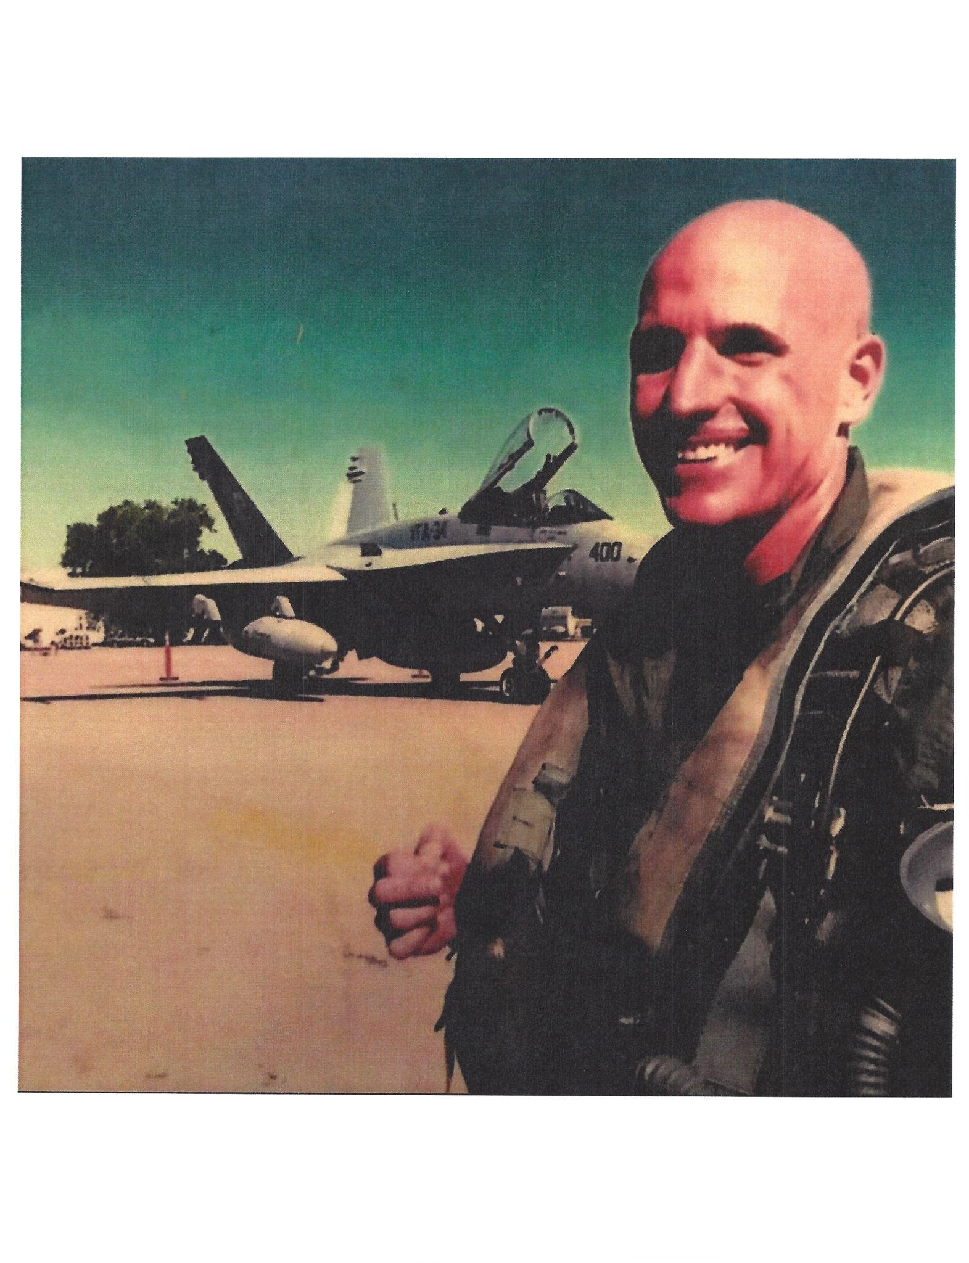Jonathan R. Biehl
(Son in Law of Ann Gaadt)
United States Navy

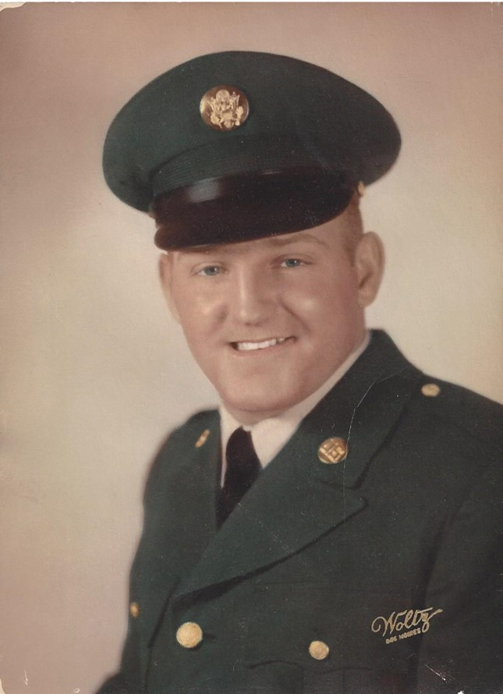
Roy W. Boschert
United States Army
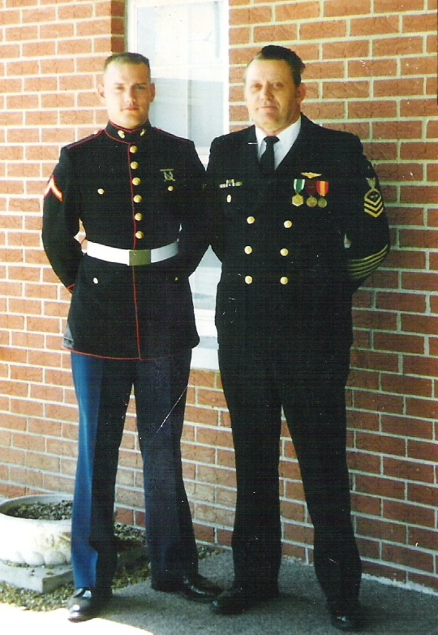
James W. Cason
(Father to Schon Cason)
United States Navy

Schon D. Cason
From left, Schon Cason (son-in-law of Ron & Lois Roberts) and James W. Cason
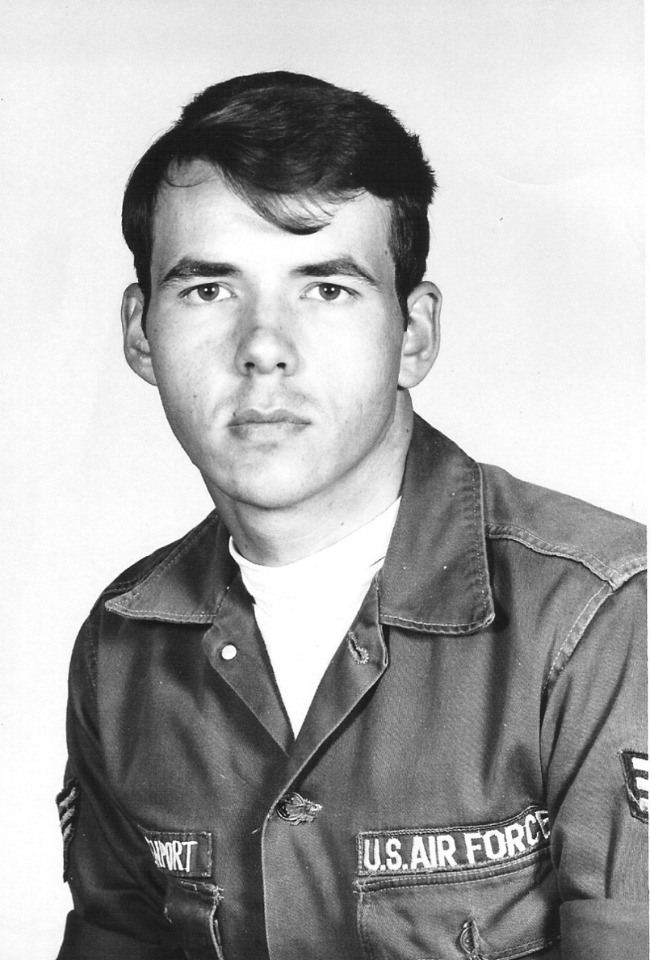
Dennis Davenport
United States Air Force

Jim Elledge
United States Navy

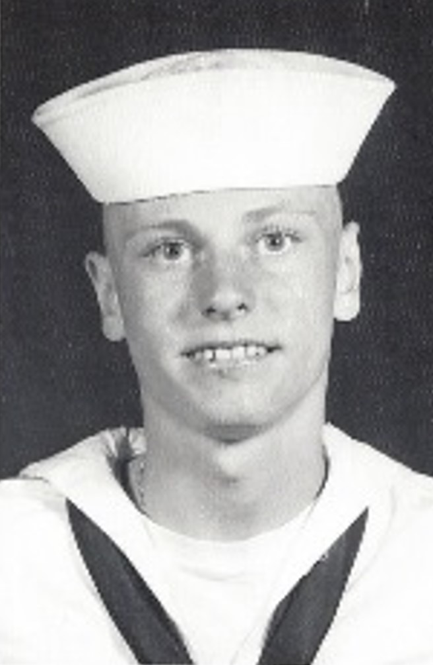
Larry T. Eickmeier
United States Navy
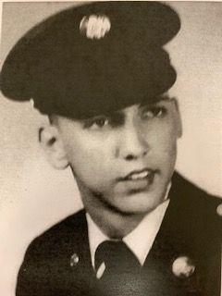
Lennes “Lenny” Fehl
United States Army

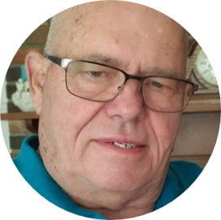
Neal Fix
United States Air Force

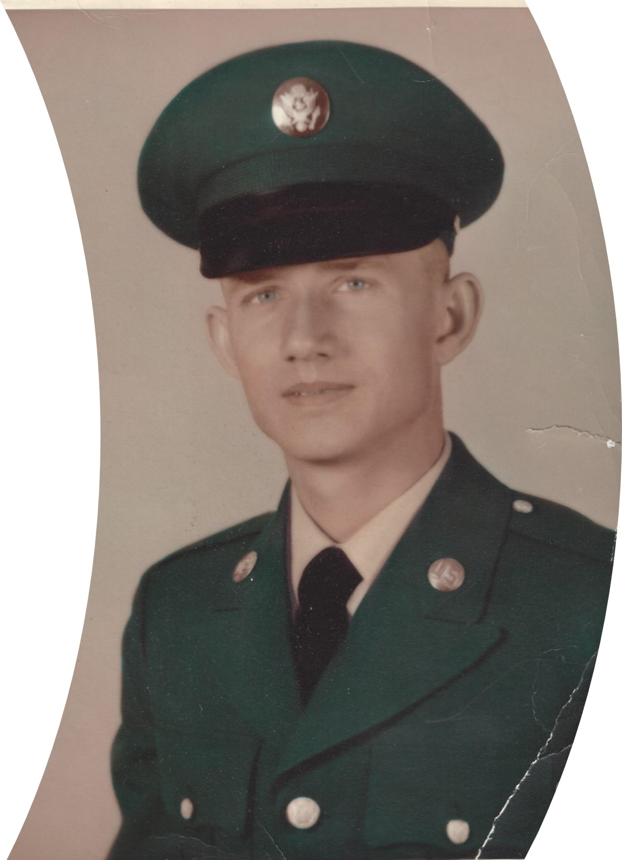
John “Jack” Frederick
Army National Guard Reserves
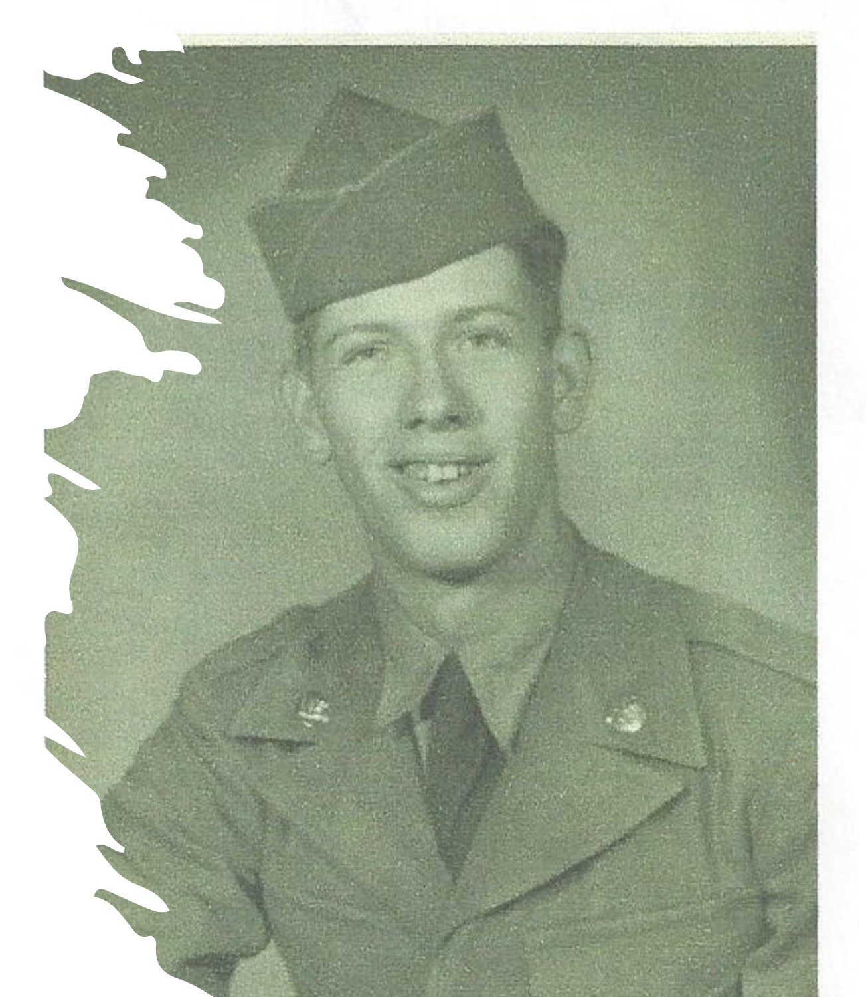
Tom Gooch
United States Army

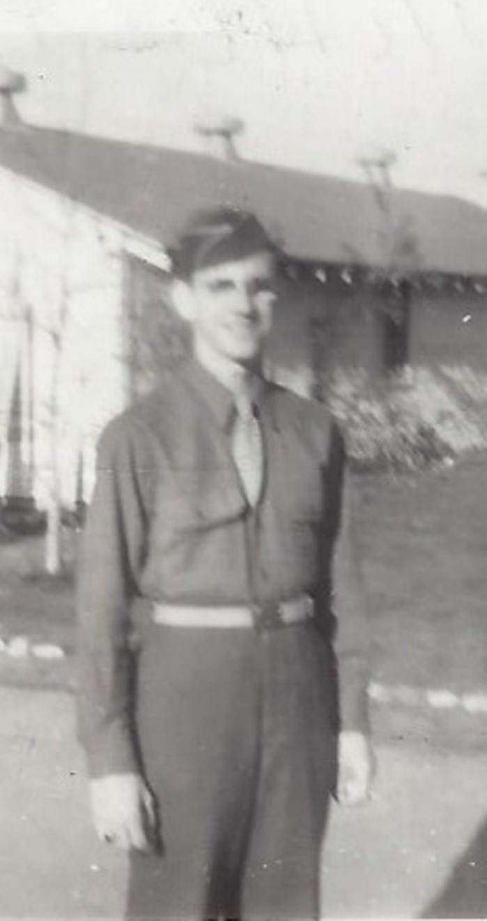
Calvin “Cal” L. Hagen
United States Army Air Corps

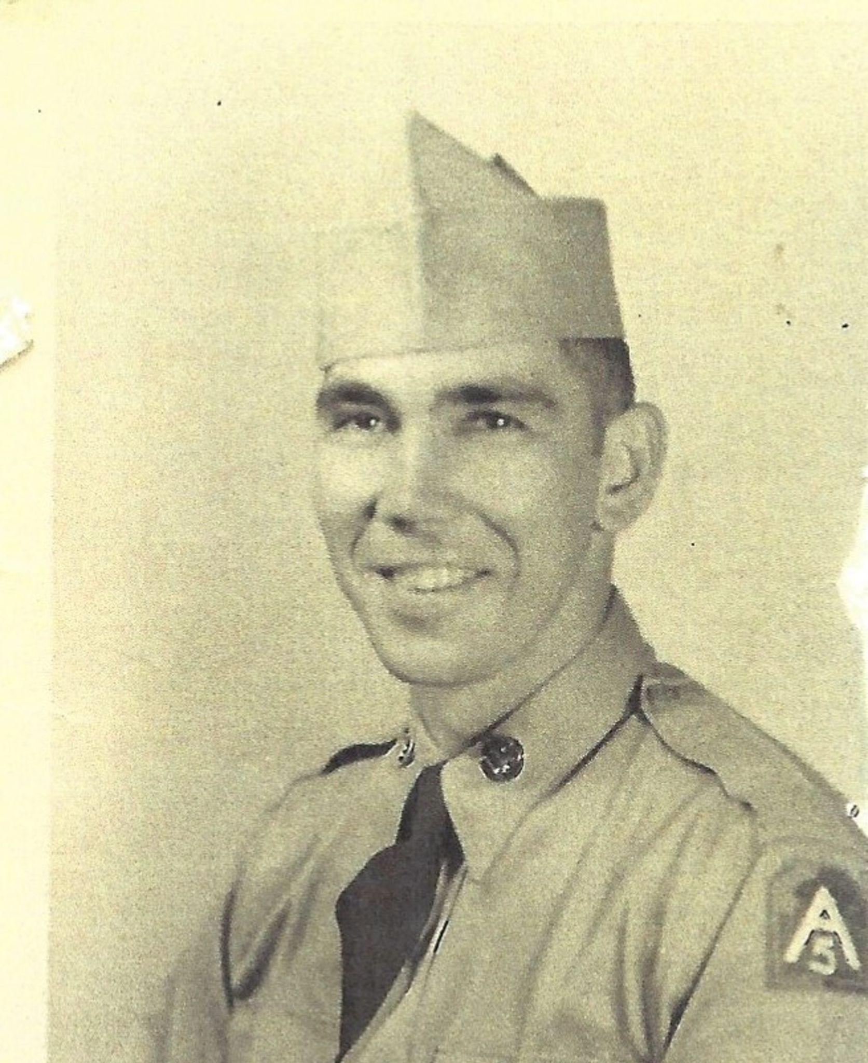
Wayne Hale
United States Army

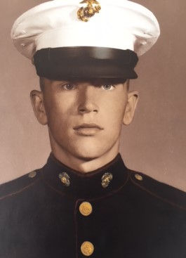
John G. Hampshire
United States Marine Corps

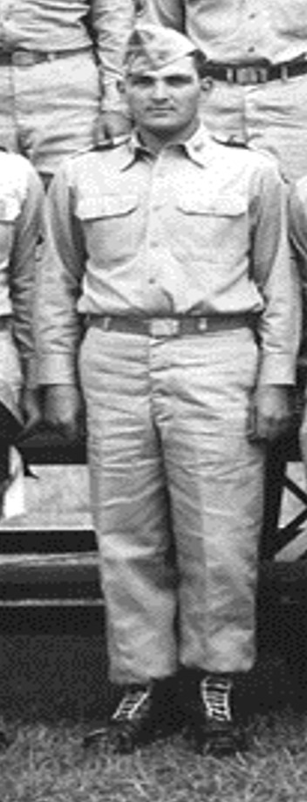
Donald W. Howell
United States Army & Missouri National Guard

Jinnielynn Howell
United States Navy

Terry Howell
United States Navy

Wesley Kolkmeier
United States Army

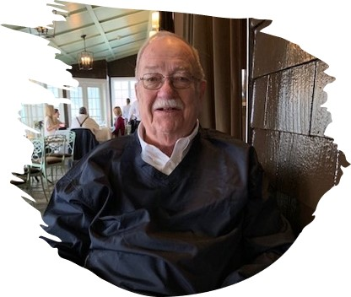Henry “Hank” Kroeger
United States Air Force / CIA
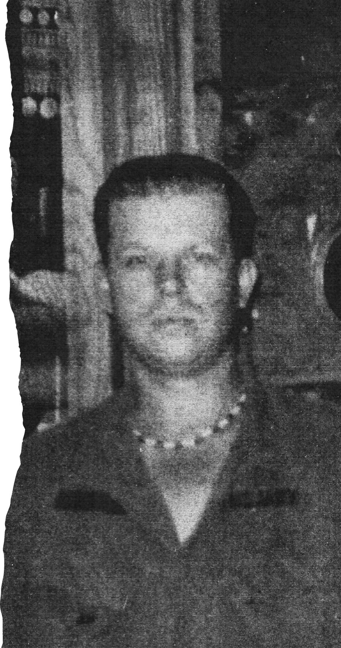
William “Bill” Lasfer
United States Army

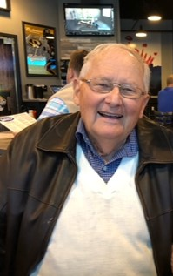
Paul Langewalter
United States Navy

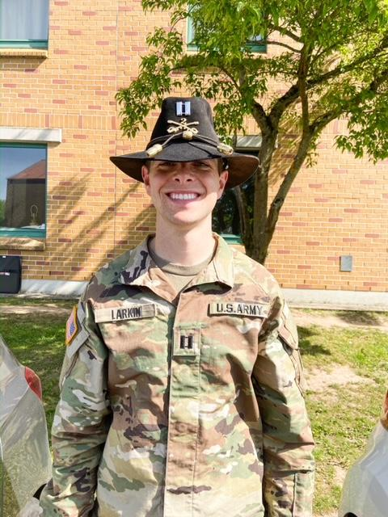
Jonathon “Jon” Larkin
(Grandson of Hank & Loire Kroeger)
United States Army

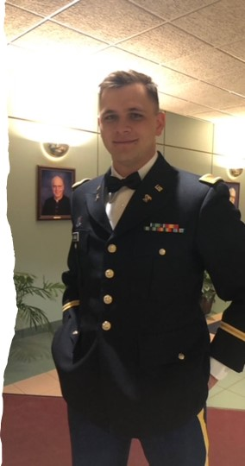
Shawn Larkin
(Grandson of Hank & Loire Kroeger)

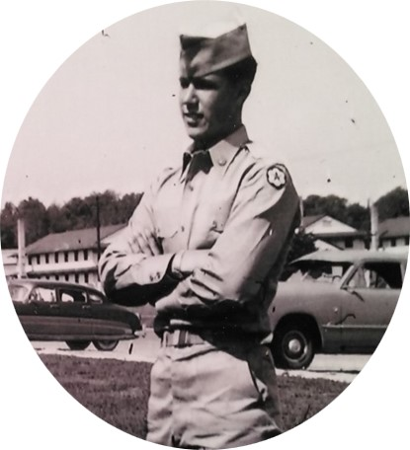
Mark Leuthauser
United States Army

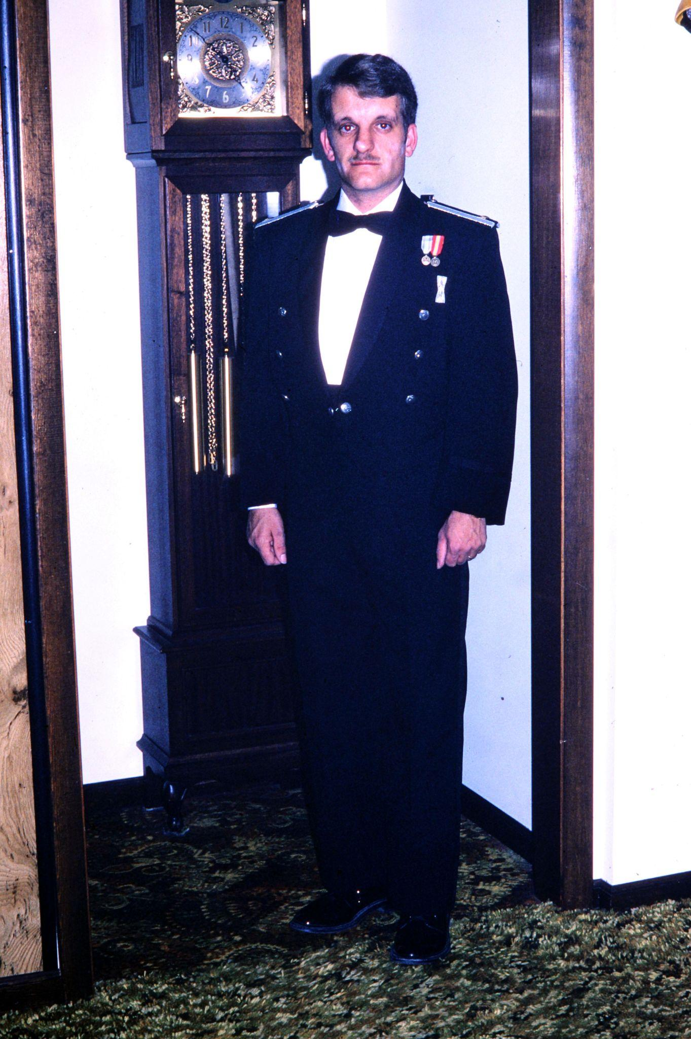
John Long
United States Air Force

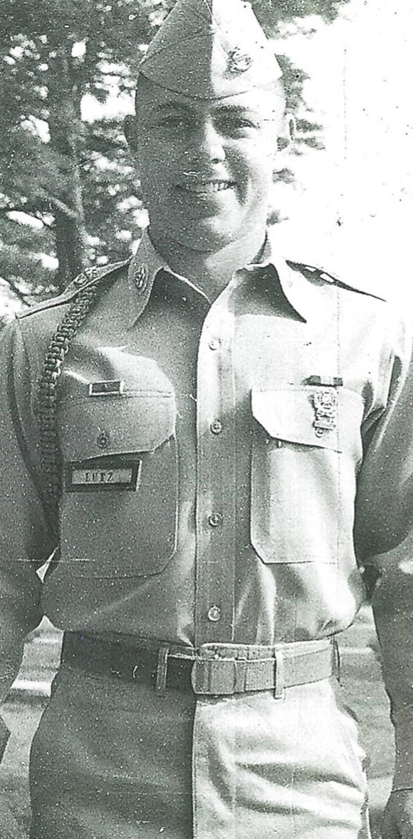
Robert Lutz
United States Army

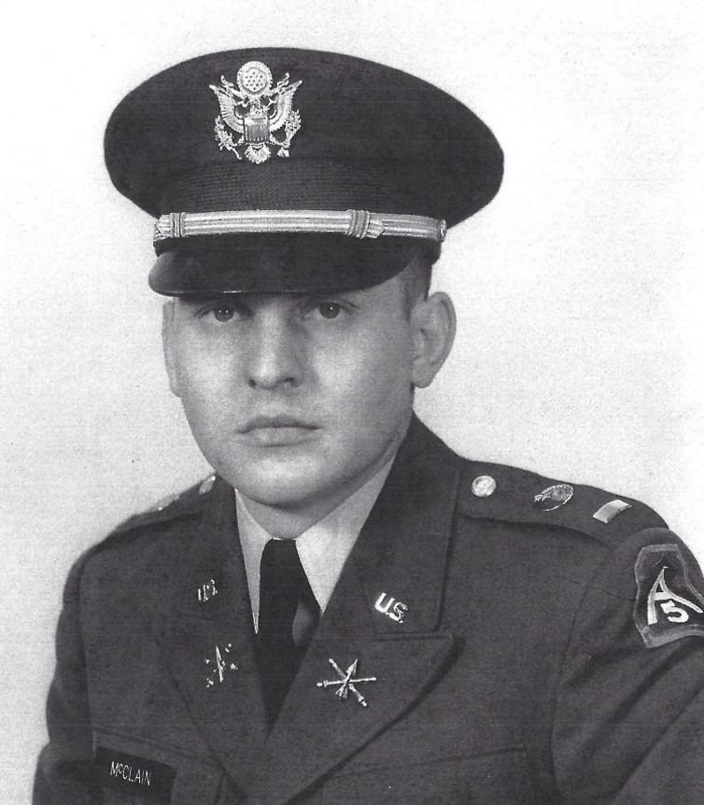
Gary Lee McClain
United States Army

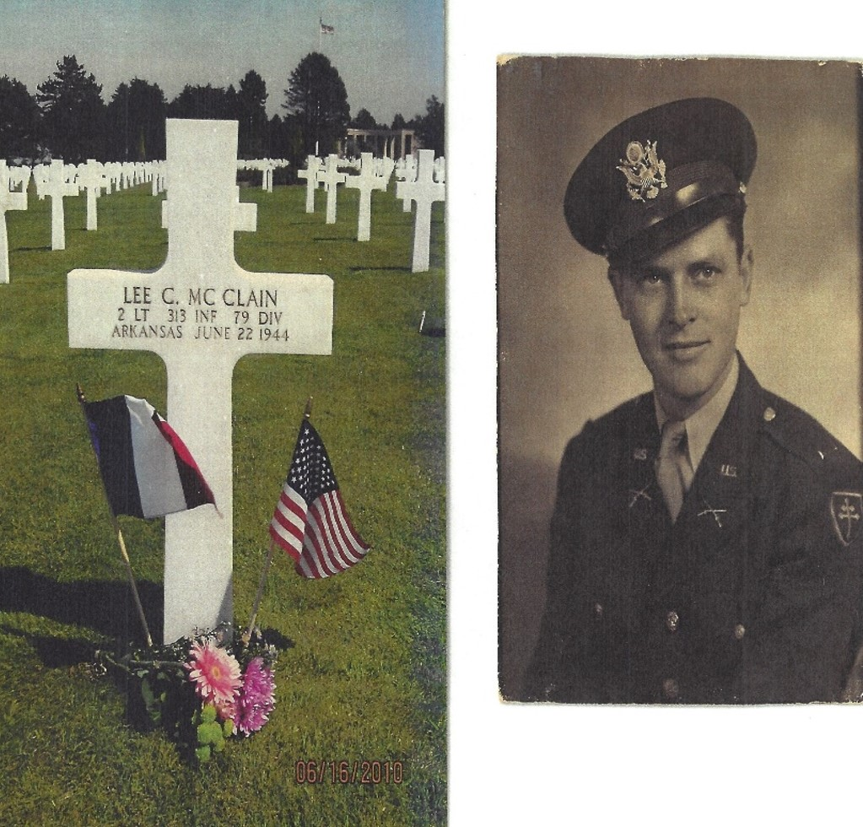
Lee C. McClain
(Father of Gary McClain)
United States Army

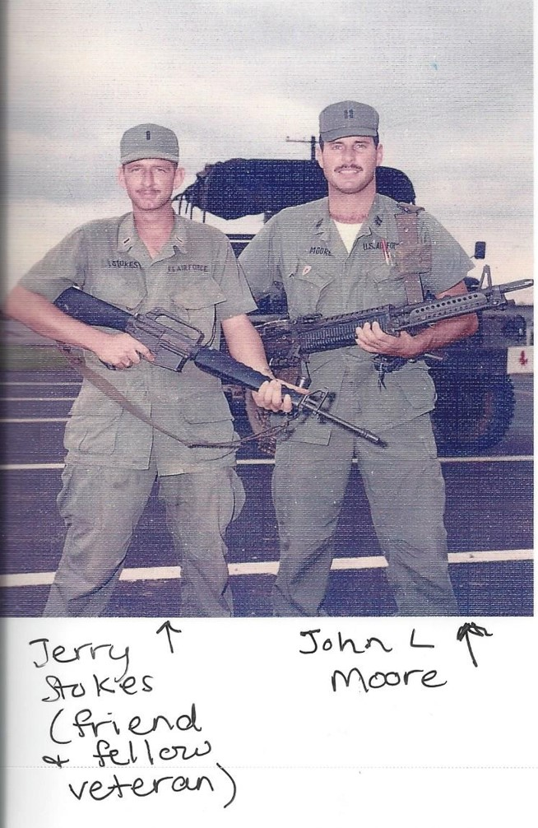
John Leroy Moore
(Father of Kristy Kniest)
United States Air Force
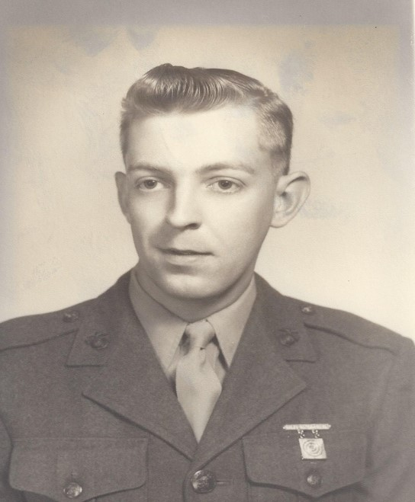
Vinson Lee Morris
United States Marine Corps

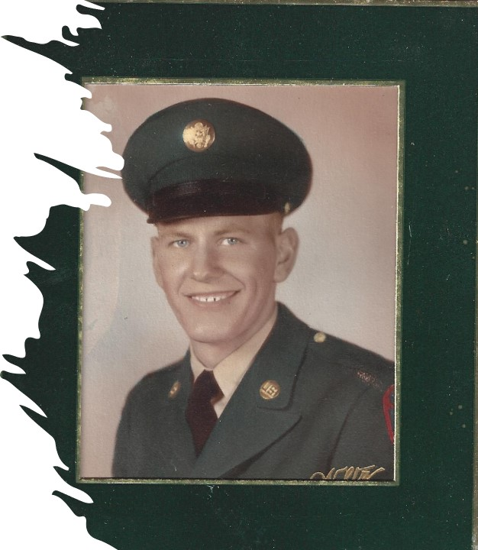
Larry Edward Nadler
United States Army

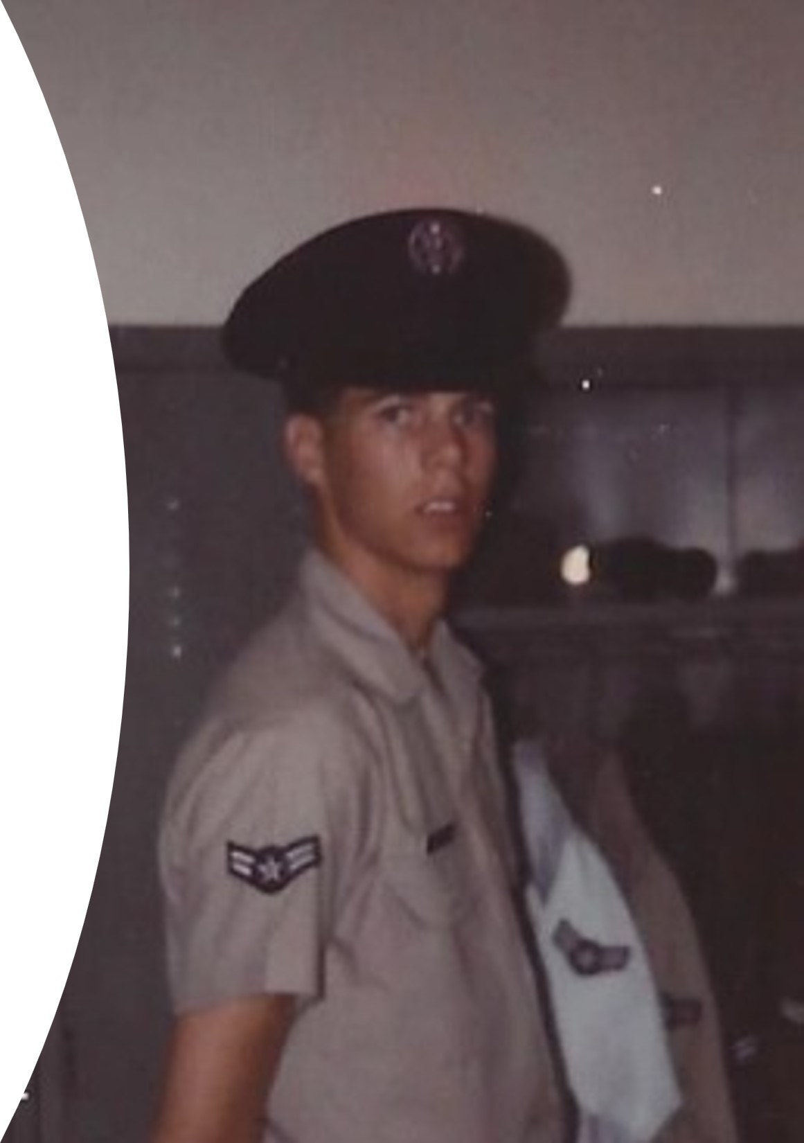
Brad Rehm
United States Air Force

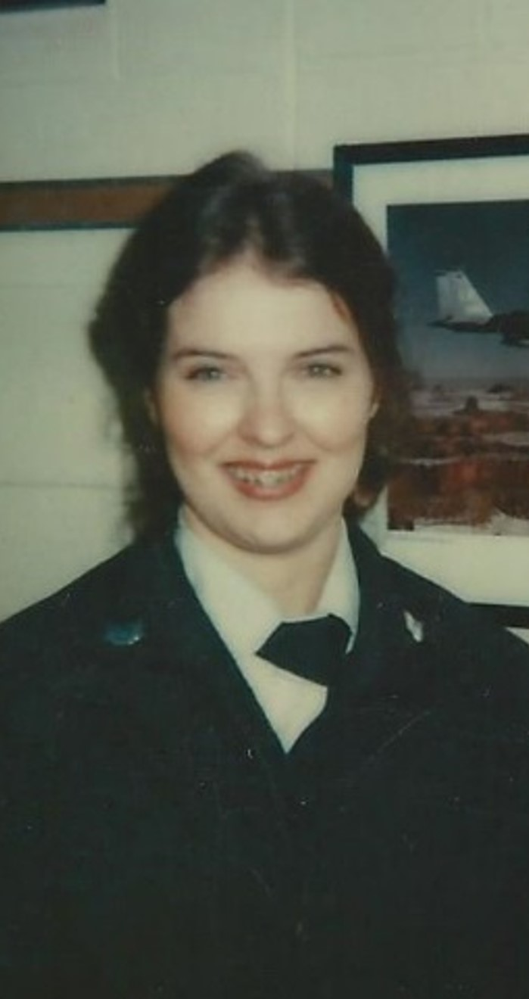
Hassie Rehm
United States Air Force

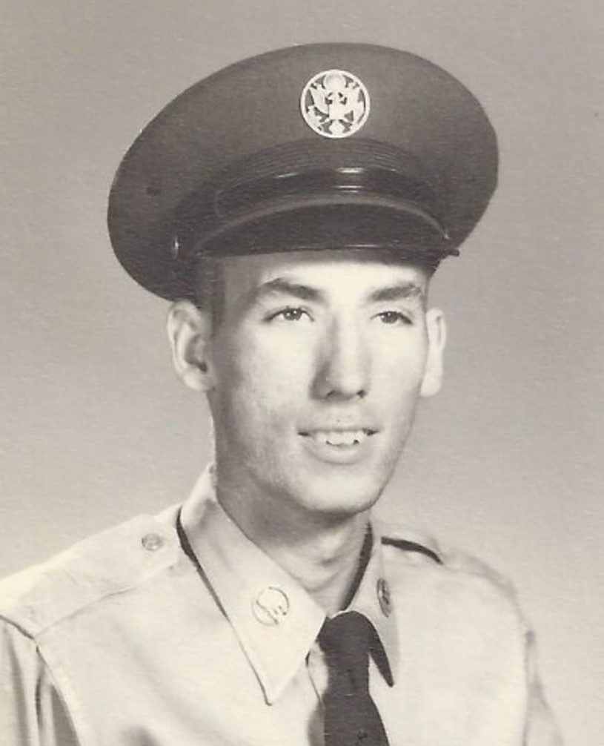
Ronnie Lee Roberts
United States Air Force

George Schlie
Missouri Army National Guard

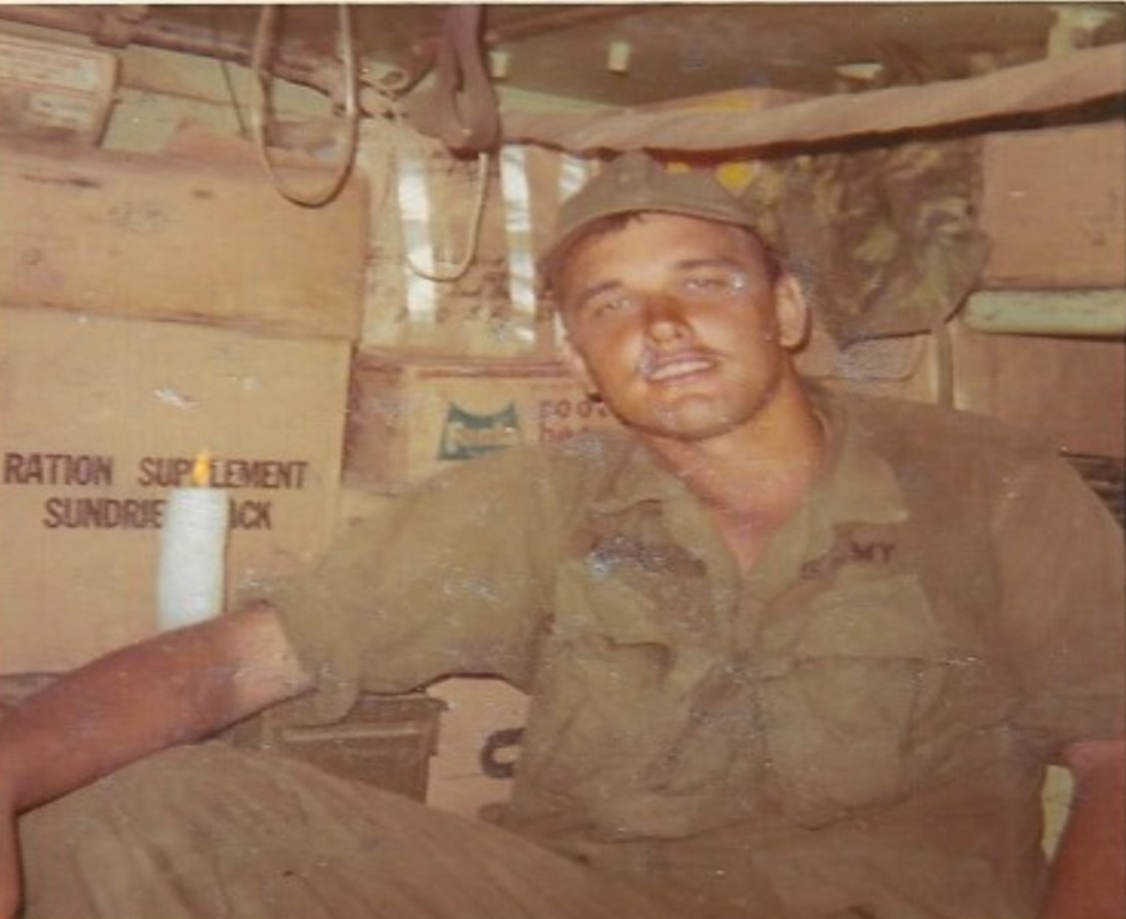
Michael Self
United States Army

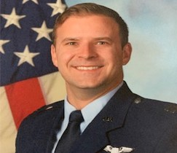
Seth Smith
(Son in Law of Bill & Karla Cunningham)
United States Air Force

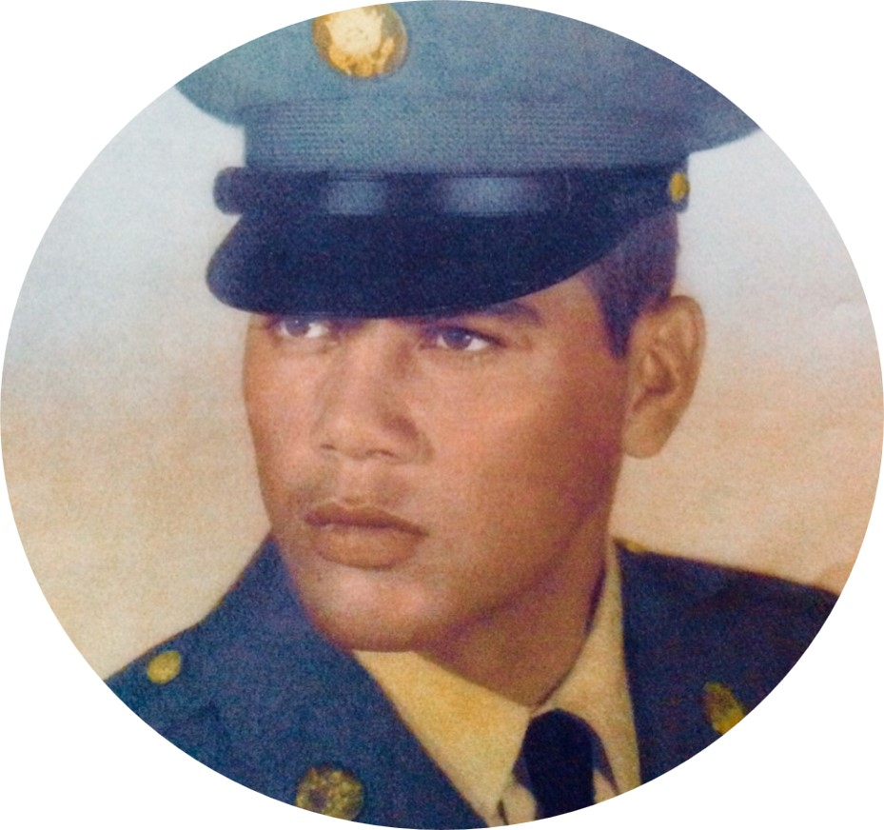
Gasper Villa
United States Army

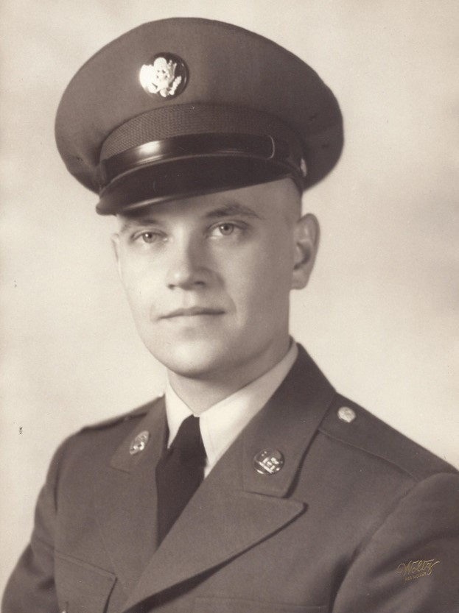
Dick Wade
United States Army
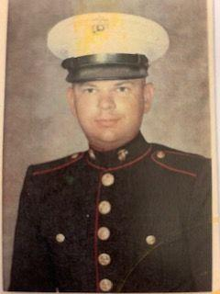
Gerald F. Wagner
United States Marine Corps Reserve

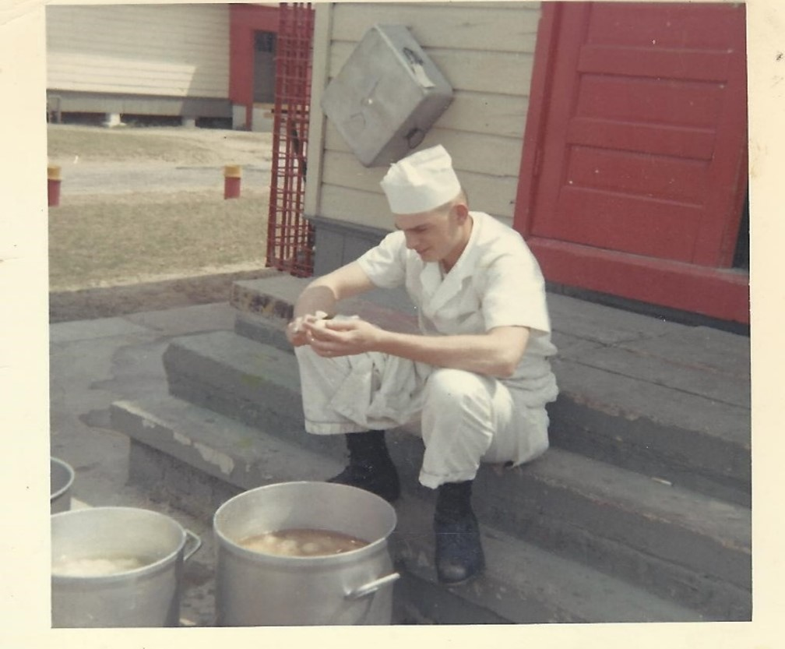
Richard Weaver
United States Army

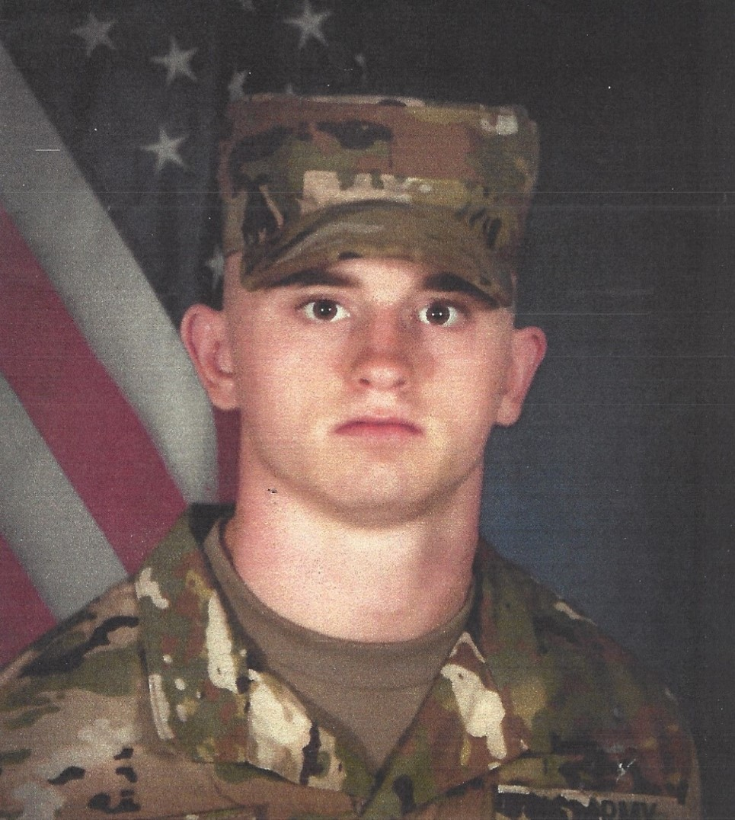
Robert Lee Welch
(Grandson of Barb Eickmeier)
United States Army
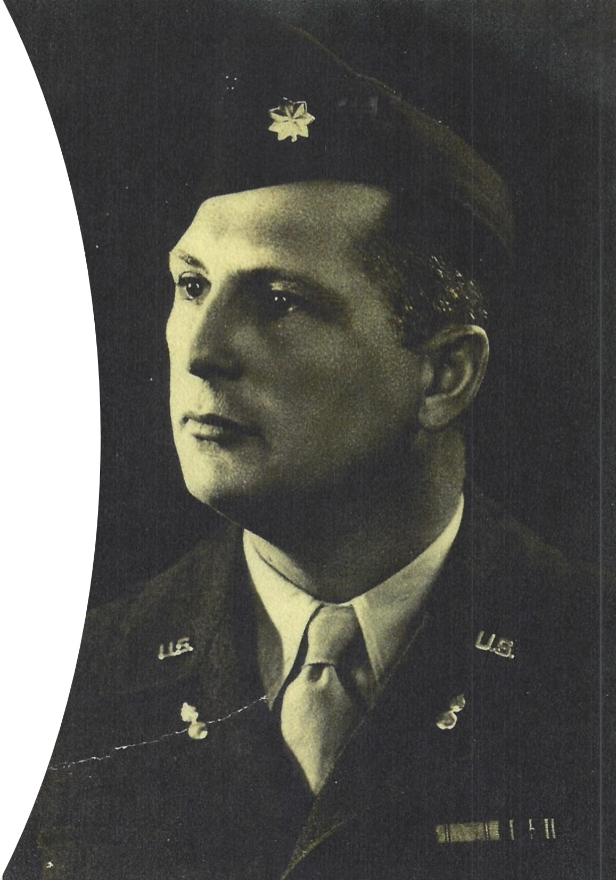
Colonel Robert Bruce Williford
(Step Father to Gary McClain)
United States Army

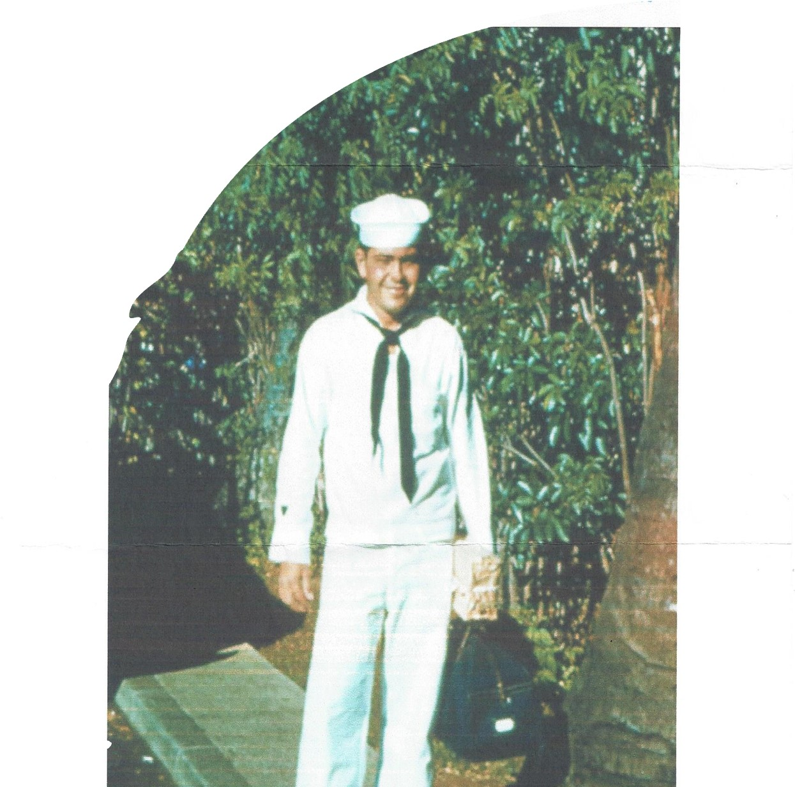
Ronald Dean Winchell
United States Coast Guard
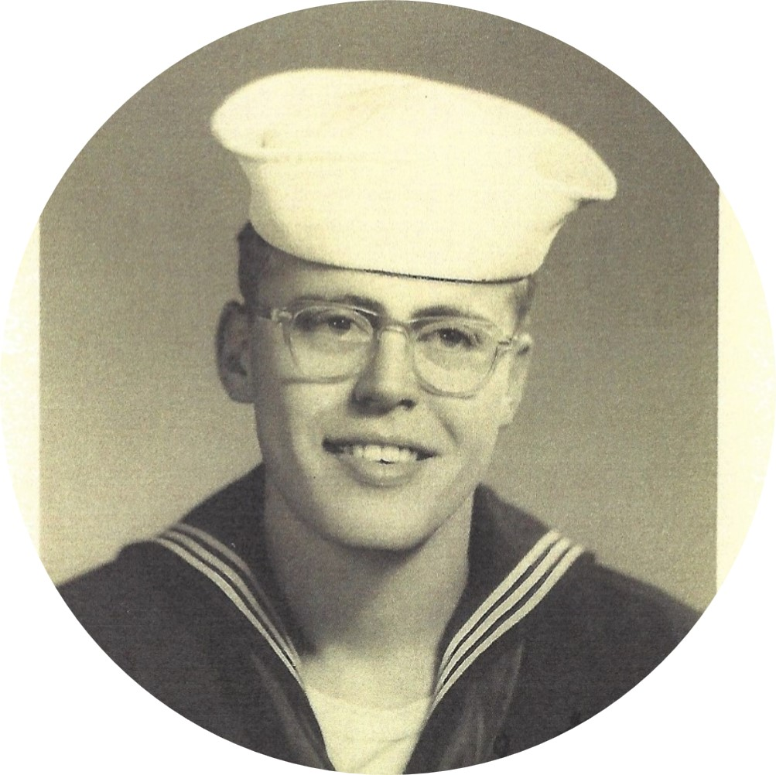
Kenneth Wolf
United States Navy

__________________________

Shane Bannister
May 8, 1967 - May 22, 2023
(Friend of Dottie Seiter)

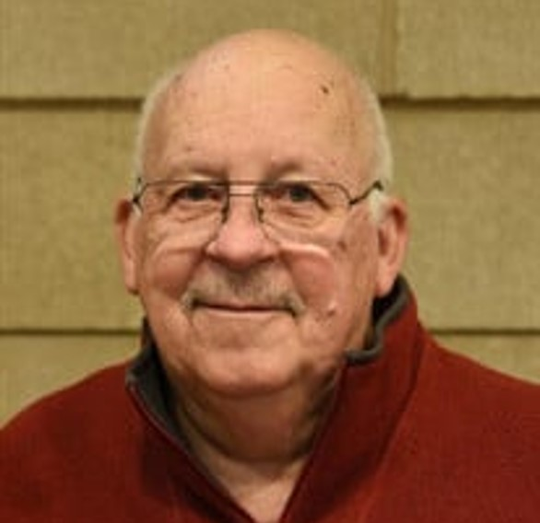
Ronald Lepp Bleeckert
July 31, 1931 - March 3, 2023

Ted Buff
May 20, 1935 - May 15, 2023
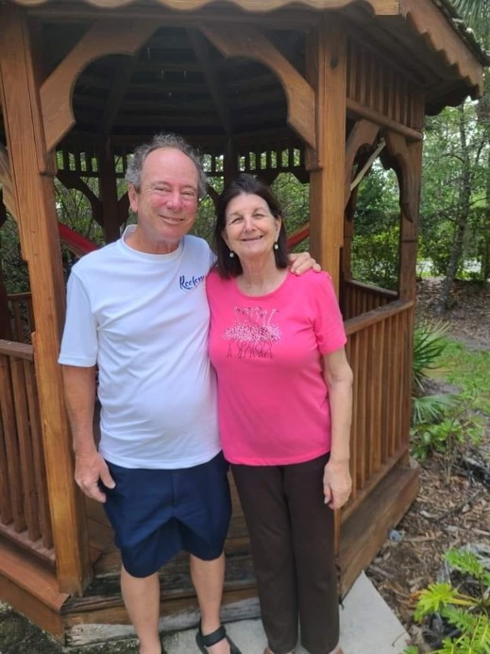
Charles Cowan
(Friend of Suzie Weaver)
January 15, 1953 -August 21, 2023

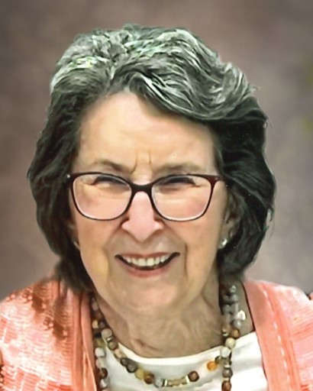
Irene East
June 10, 1931 - July 26, 2023

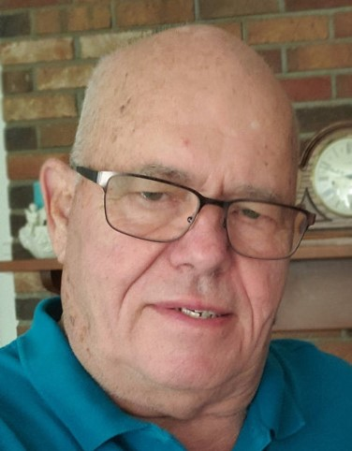
Neal F. L. Fix
January 18, 1942 - January 28, 2023

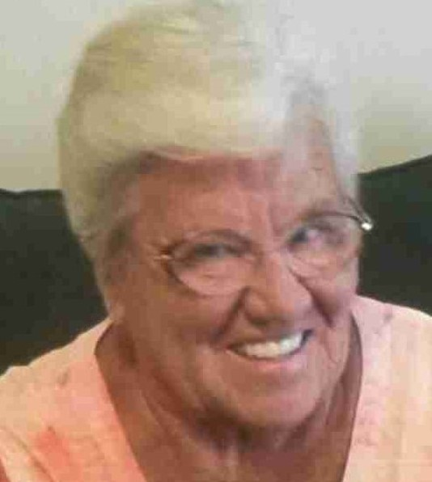
Carol Ann Gurtrude (Null) Keiser
September 11, 1941 - September 30, 2023

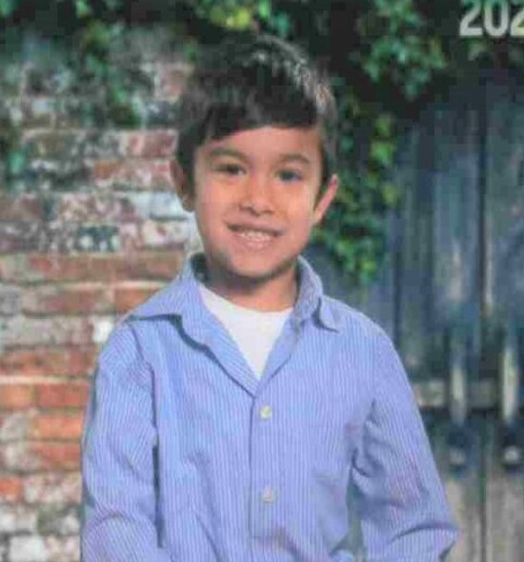
Cole Jacob Keiser
May 17, 2017 - April 16, 2023

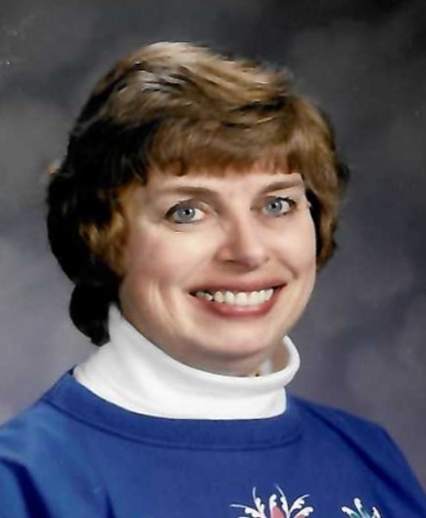
Mary Lauer
(Friend of Suzie Weaver)
August 6, 1943 - July 2, 2023
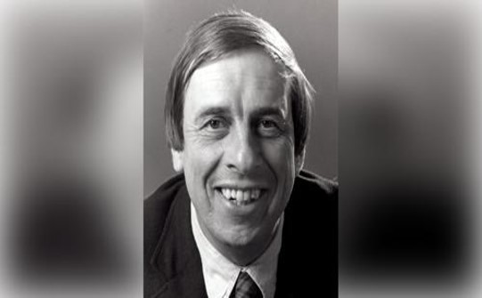
Rev. David Lauer
(Friend of Suzie Weaver)
November 14, 1941 - September 2, 2023

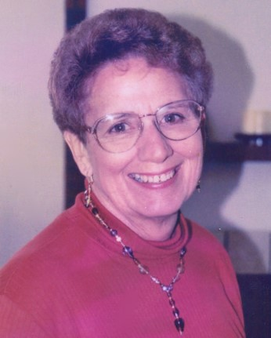
Virginia “Ginny” Lee Loika
April 26, 1935 - May 23, 2023

John Long
1946-2021

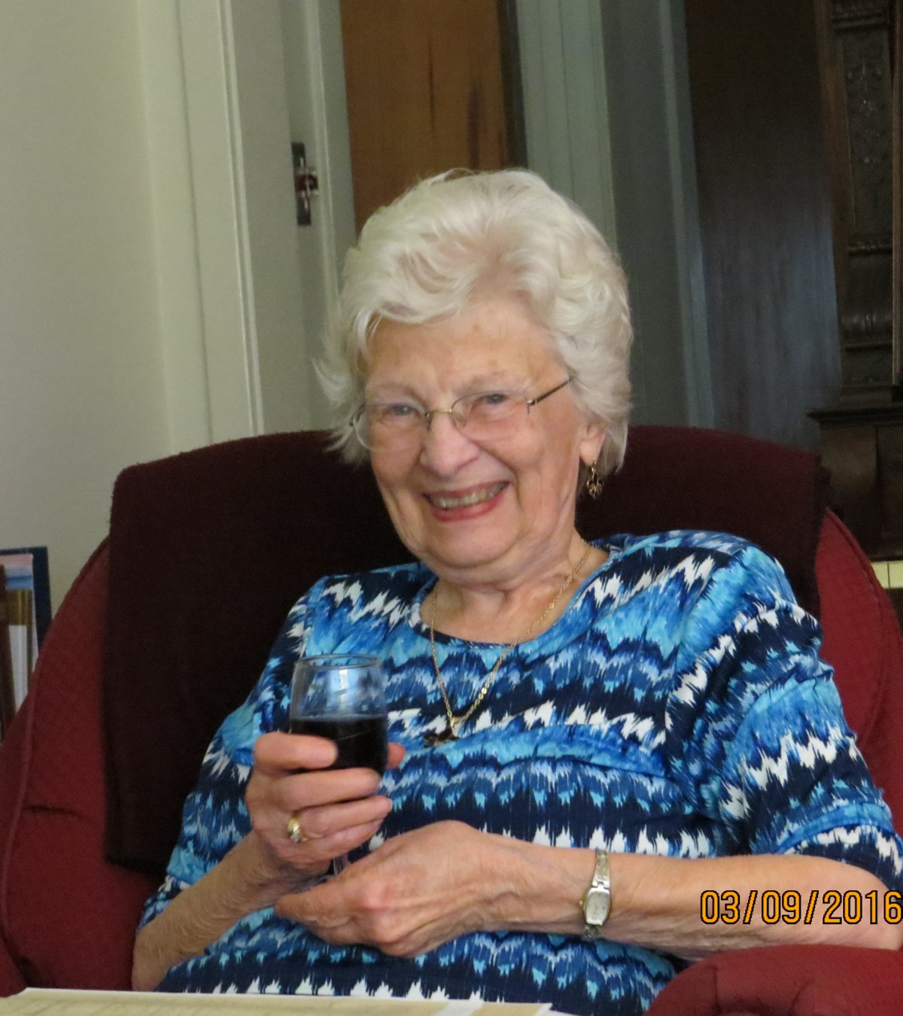
Ruth Nevels
(Friend of Suzie Weaver)
January 5, 1931 - April 28, 2023
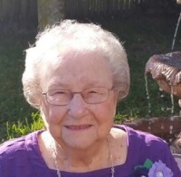
Joy Radin
(Friend of Dottie Seiter)
March 1, 1929 - July 29, 2023

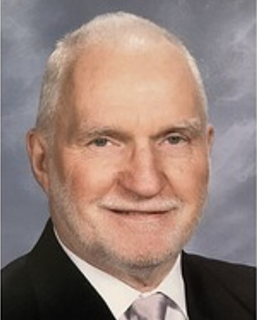
Deacon John “Jack” Shannon
September 14, 1931 - January 16, 2023

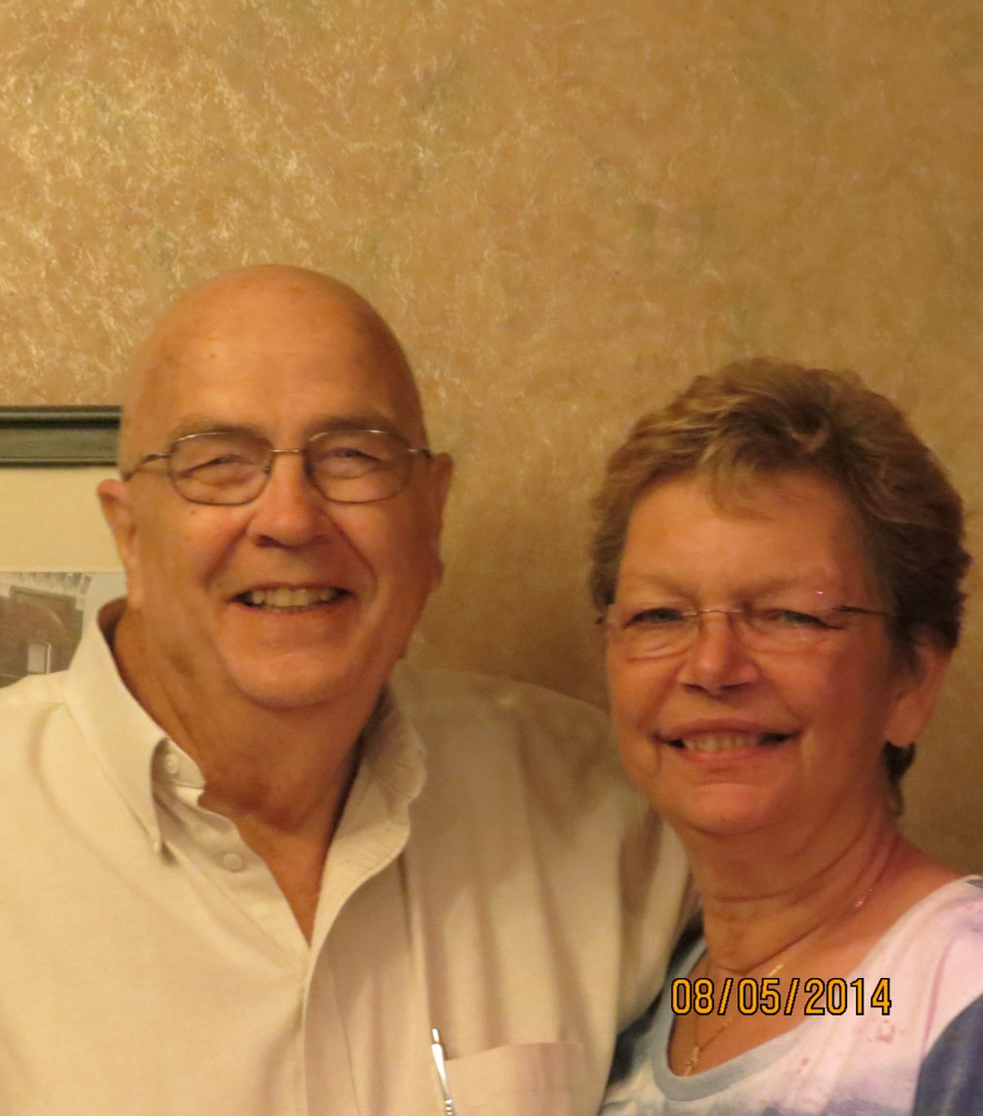
Lois Sorth
(Friend of Suzie Weaver)
August 27, 1948 - January 19, 2023

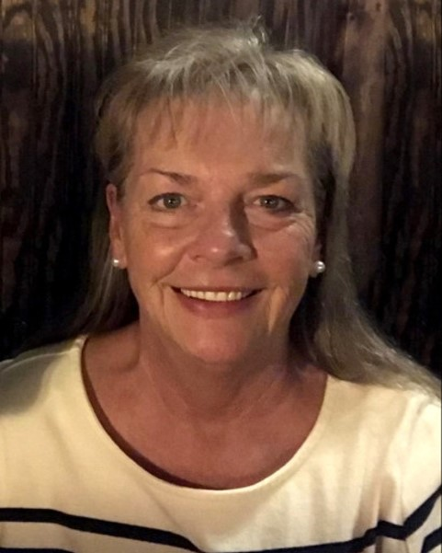
Linda M. King-Suttkus
(Friend of Dottie Seiter)
January 10, 1954 - December 5, 2023
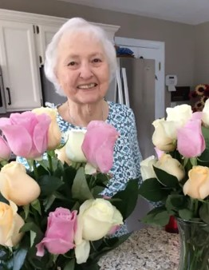
Mary Ellen Taylor
November 12, 1931 - August 2, 2023
__________________________
Join us on Sunday November 12th after Worship Service for a Luncheon, as we say Farewell & Good Luck to Pastor Poe.

See the sign up sheet on the bulletin board to RSVP if you will be attending.
__________________________

Starting TUESDAY, November 15, Men’s and Women’s Bible Study will be joining together every Tuesday at Scrambled Egg at 9:30am. Come at 9:30 AM if you want to have breakfast with the men or come between 9:45 - 10 AM if you plan to have breakfast earlier on your own. Everyone is Welcome to Join!
__________________________
KEEPING HANDS AND HEARTS WARM THIS WINTER

The temperature is dropping, which means it is time for our hat and mitten collection for Shower of Love.

These donations will be distributed to local nonprofits serving pregnant women, babies, and fragile families in crisis residing in St. Charles County and Lincoln County, Missouri.

At this time we will also be collecting the scarves that many of you have been busy crocheting throughout the year. These will also be given to the Shower of Love to distribute to those that need the extra warmth this winter.

If you would like to donate new hats and mittens for ages 5-18 please hang them on the fall tree located in the sanctuary November 5 through November 26.

Remember if you have scarves that you have crochet bring them in and hang them on the tree too.
__________________________

STEWARDSHIP CAMPAIGN 2024

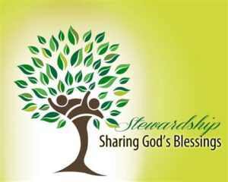
Over the course of October, you will hear from other members on why they support St. John's UCC with their pledges and offerings.
Come and listen to these powerful stories of changed lives each Sunday in October.

Stewardship Sunday will be held on Sunday, November 12th when you get to celebrate God's generosity by making your yearly pledge to the operating and building funds of
St. John's UCC.

Please prayerfully consider what you can give towards 2024 to help us continue to make a difference in people's lives. Thank you.

Rev. David Poe,
Intentional Interim Minister
__________________________

“ JOYFULLY RING HIS PRAISES” HANDBELL
MINISTRY
Our choir rings in the 10 AM worship service the 2nd Sunday each month: Sept. thru May

Practices on Wednesday evenings 5:30 to 6:50. August thru mid-May
__________________________
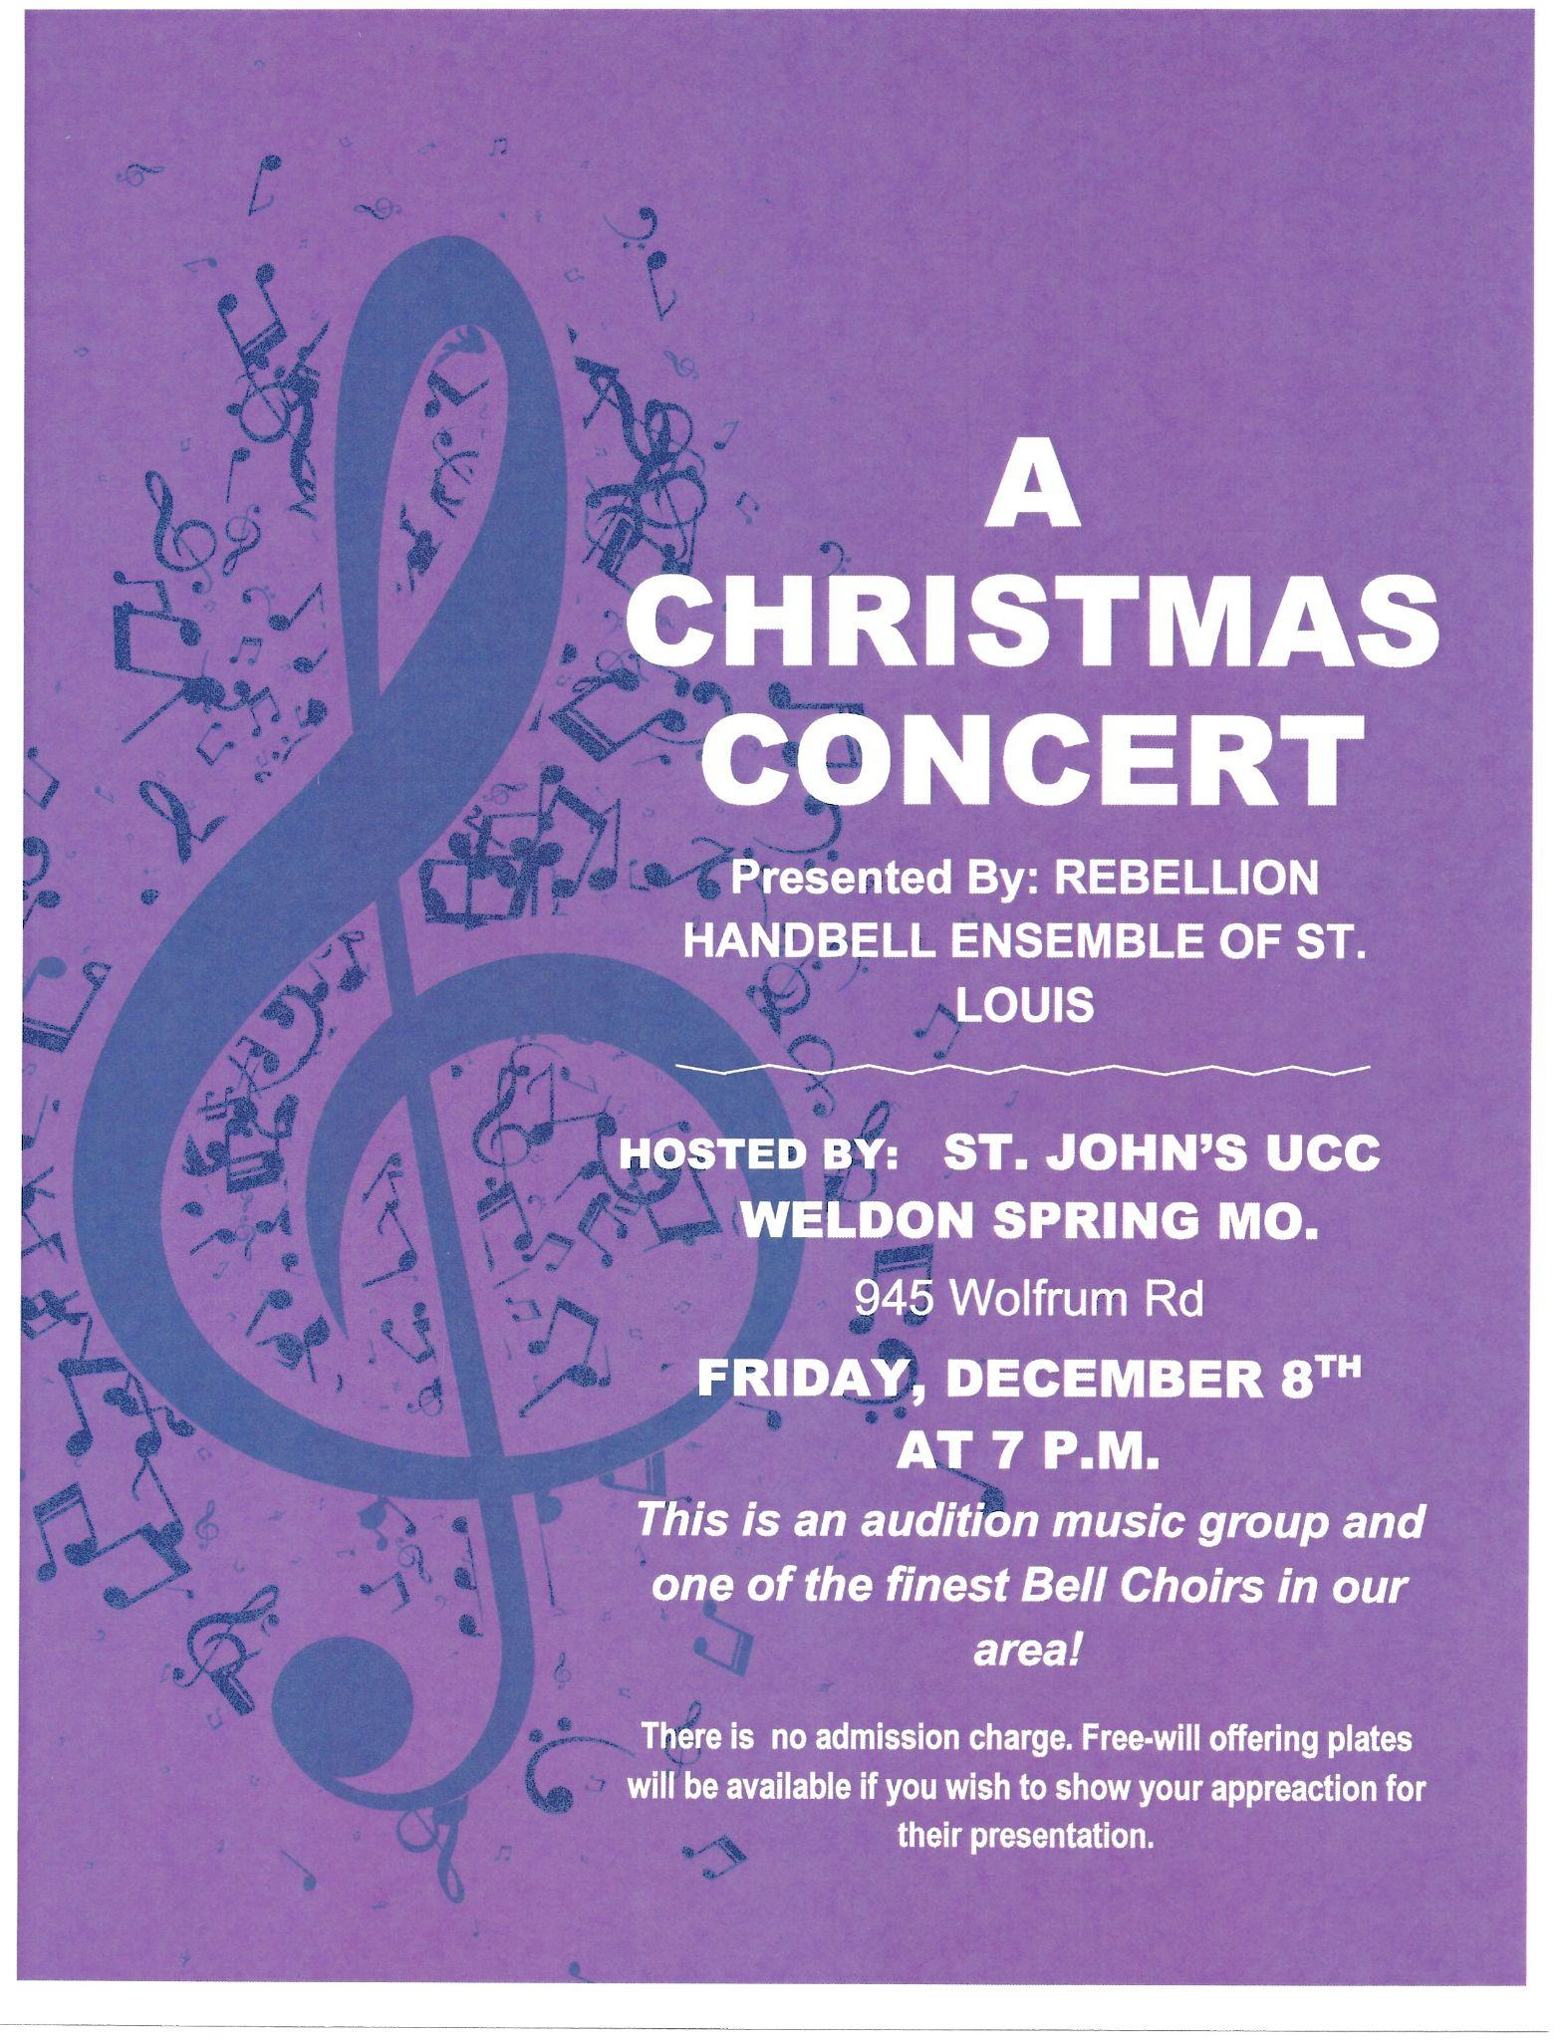
We are excited to announce that St. John’s is hosting A Christmas Concert presented by Rebellion Handbell Ensemble of St. Louis on Friday December 8th at 7pm.
This is an audition music group and one of the finest Bell Choirs in our area!
There is no admission charge. Free-will offering plates will be available if you wish to show your appreciation for their presentation.
This is a great opportunity for our church. Please share this announcement with your family and friends.
__________________________
ST. JOHN’S SINGERS FOR THE SAVIOR
Our Children and Youth Music Program rehearsal is every Sunday at 11:15am following the close of worship and Sunday School.
Please contact our Director, Joyce Ann McClain, at 636-441-0121 for more details.
__________________________

Would you like to Volunteer to be a Liturgist, an Usher/Greeter, a Bell Ringer or even a Sound Technician or how about adding yourself to another position.

We are always looking for members. Contact Jewel Nadler 636-373-1860.
__________________________

LENDING LIBRARY
Looking for some books to help increase your understanding and inspire your devotion to Jesus?
Check out our new lending library, which is located in the large basket next to the main building doors.
You can take a book, or leave one to share. Just remember to return the book you take within a month, so others can benefit from it as well. Thanks.
__________________________

F.I.S.H. FOOD PANTRY NEEDS FOR Nov. 2023

Applesauce
Jelly
Pork and beans
Canned Yams
Toilet Tissue
Pumpkin
Can Pasta
Adult toothpaste
Can Chili
Cereal/Oatmeal
Tuna Helper
Shampoo - Any Type
Conditioner - Any Type
Men's Deodorant
Diapers - Newborn
Pull Ups - Any Size
Kids Shoes & Boots - All Sizes & Genders - New or Lightly Worn
Queen and Twin fitted sheets
Blankets

May you all be blessed for your generosity!

Place your donations in the grocery cart in the fellowship hall.
__________________________
MISSION & CARING
MINISTRIES TEAM NEWS

Homebound? If you know of someone who should be included on our shut-in list to receive quarterly Holy Communion from the minister and occasional visits
and gifts from our team, please contact the church office.

Festival of Sharing Eyeglass Collection Old eyeglasses or sunglasses need to be Prescription glasses. They can be dropped off in the bin in fellowship hall. We cannot take glass cases or non-prescription sunglasses.
______________________
Support Ronald McDonald House - bring in your soda tabs!

Come join us… Mission & Caring meets on the second Tuesday of each month in the fellowship hall at
6pm
__________________________

Our congregation Socked it to Socktober!

The Mission and Caring Committee would like to thank you for all of the socks donated for Shower of Love that will distribute them to other local non-profits serving pregnant women, babies, and fragile families in crisis residing in St. Charles County and Lincoln County, Missouri.
A total of 280 pairs of socks were collected:

18 pairs for infants
39 pairs for toddlers
66 pairs for youth
79 pairs for teens
78 pairs for adults
_________________________

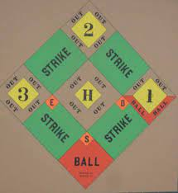

ST. JOHN’S MENS DART BALL SCHEDULE

GAMES START AT 7:30P.M.

Monday, Nov. 6
Our Savior at Friedens
St. John’s - Bye

Monday, Nov. 13
St. John’s at Friedens
Our Savior - Bye

Monday, Nov. 20
St. John’s at Our Savior
Friedens - Bye
If you are interested in joining the Men's team call Dick Wade at 636-448-0238
__________________________

LET’S SUPPORT OUR LOCAL UCC CHURCH’S

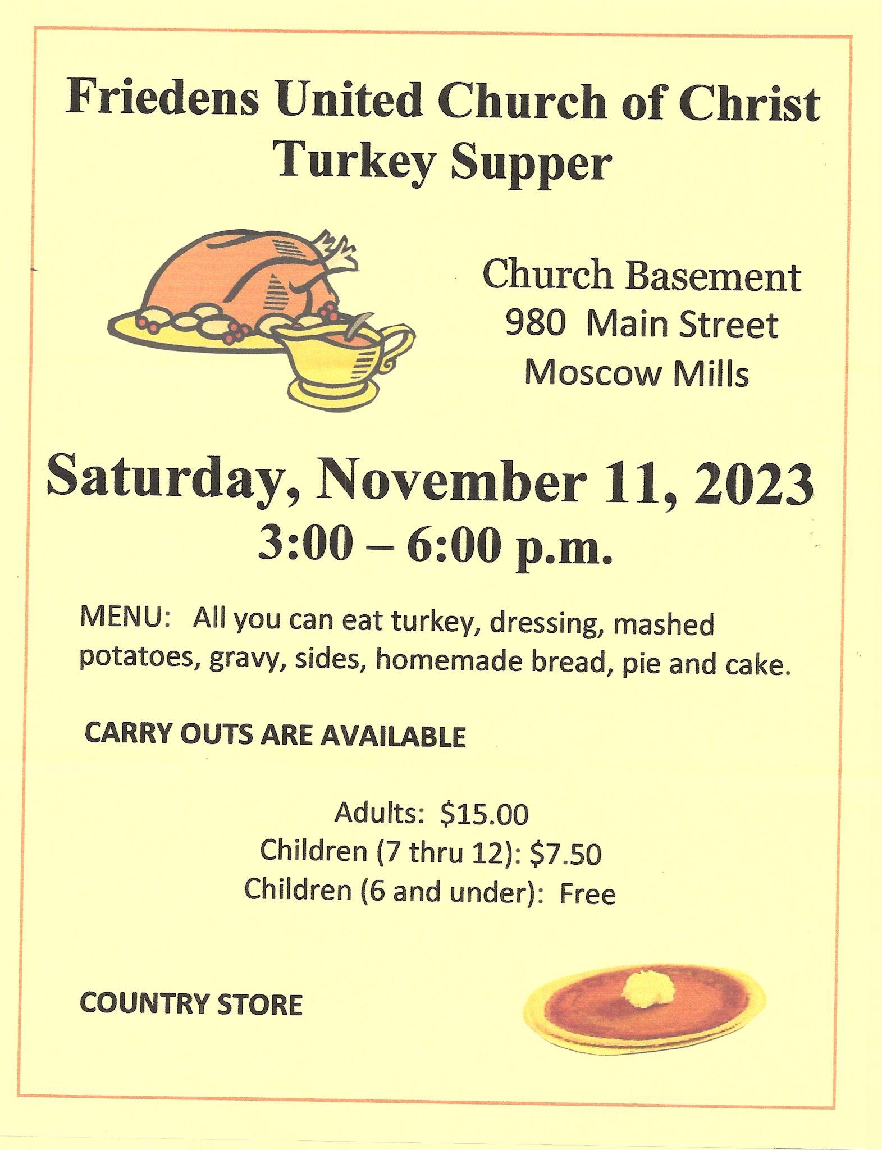

__________________________

Reminder: If you have a change of address or change in phone number please reach out to the church office 636-926-8995 so we can update our files.
__________________________

OUR HOMEBOUND FRIENDS

Martha Cook Marian Lonning
Shelia Fredrick Rita Marcum
Calvin Hagen Chris Savage
Barb Hofstetter George Schlie
Pat Honaker Edie Shave
Don Howell Rick Weaver Hank Kroeger
Mary Ellen Dieckmann David & Dorothy Kapeller
__________________________
Don't forget to bring your recycled cans to church!
There is a canister out in the trash coral that is marked
"Aluminum Cans"
__________________________

Jerry & Polly Wagner 11/15
Wayne & Linda Dimmic 11/29
_______________________
Alice Wolf 11/02
Ken Lippincott 11/03
Calvin Hagen 11/04
Frances Hardwick 11/05
Joan Huntebrinker 11/08
Jenna Marco 11/08
Donna Bleeckert 11/13
Charlotte Shelburne 11/13
Jewel Nadler 11/15
Natalie Wooten 11/15
Ed Struckman 11/16
John Hampshire 11/17
Dick Wade 11/17
Wes Kolkmeier 11/22
Lily Morton 11/23
Karla Cunningham 11/26
Barbara Eickmeier 11/26
Polly Wagner 11/26
Cheryl Saeuberlich 11/27
__________________________

ALTAR FLOWERS
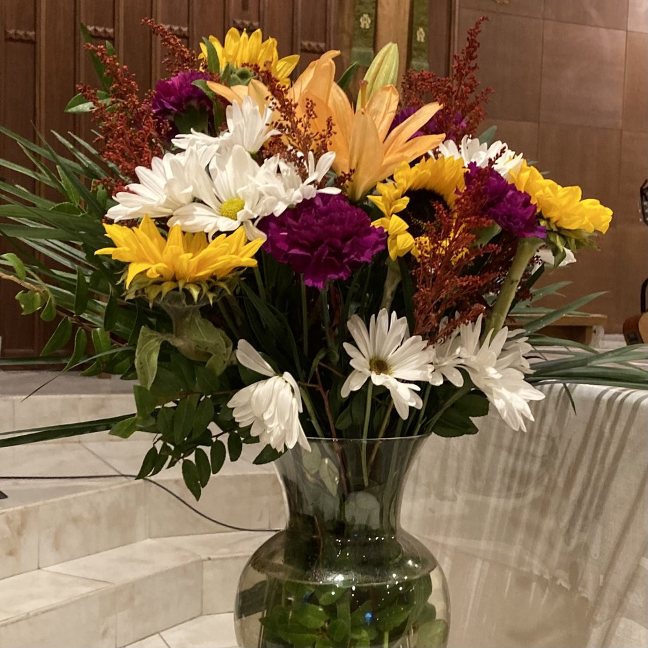

Is there someone that you would like to remember, or honor? Special anniversary, birthday, or graduation to recognize?

If so, contact the church office (636) 926-8995 to sponsor chancel flowers in their name(s). The cost is $35 per arrangement
__________________________

PRAYER LIST

Prayer request cards are located on the small table as you enter for worship. Please fill one out and give it to the Minister or an Usher. Make sure you have the person’s permission before filling out a card.

Comfort and Healing: Mary Ellen Dieckmann; Martha Cook; Elizabeth Gilliam; Jeff Kolkmeier; Edie Shave (Hospice); Marian Lonning; Hank Kroeger.

Others for whom we have concern: Ron Gravemann, (Brother of Diane Falkner); Eric (Allan Hopkins, niece’s husband 46 years old diagnosed with stage 4 Pancreatic Cancer); Michael Wooten (Father-In-Law of Natalie Wooten, diagnosed with Lung Cancer); Diane Weilmuenster (Heart Problems, Sister of David & Jill Carr); Michell Lenz (Niece of Jeff & Debbie Kolkmeier Diagnosed with Breast Cancer); Janet Iler (Brain Cancer Surgery, Friend of Rhonda Hanne); Shannon Boland and Family (friend of Connie Wildt, battling cancer); Dylan Jensen (per Jinnielynn Howell).
Please let us know when it’s time to remove a request from the list.
______________________

Pastor David Poe,
Intentional Interim Minister

Mary Trostel
Office Administrator
Office Hours: M-F, 9 a.m. to 3 p.m.
Office@stjohnsweldonspring.com

St. John’s UCC 945 Wolfrum Rd., Weldon Spring MO, 63304 | Phone:
(636) 926-8995
www.stjohnsweldonspring.com

