Weekly Announcements
12/17/2023
…………………….

This Week’s Participants: Rev. Patrick Gruber, Church Pastor; Ann Gaadt, Organist Pianist & Choir Director; Ken Waterman, organist Pianist; Joyce Ann McClain, Handbell Director & Children’s & Youth Choir Director; Bryan Wildt, Liturgist; Connie Wildt, Greeter; Ken Waterman, Connie Wildt, Jerry & Polly Wagner, Ushers; Ron Winchell, David Carr, Sound Booth; John Hampshire, Bell Ringer; Bernice Dodge, Gayle Winchell, Nursery; Natalie Wooten and Ellen Waterman, SonShine Kids.

Pastoral Care: If you find yourself experiencing illness, hospitalization, grief, or other critical challenges, contact us at (636) 926-8995. For emergencies, contact Pastor Patrick Gruber, (636) 253-1287.

Financial Contributions: you can give electronically via our website, set up automatic monthly contributions, or receive weekly envelopes, contact the office for assistance.

Announcements: If you would like to have something announced in the bulletin, please email the information to office@stjohnsweldonspring.com no later than 10 a.m. each Thursday. Thank you!

Use your QR reader app to make an electronic contribution to St. John’s UCC. Thank you. ______________________
Last Week’s Worship Attendance: 102
Facebook Views: N/A
YouTube Channel Views: 17
______________________
THIS WEEK’S
TOP STORIES
__________________________

It is really important that we don't forget to wear name tags every Sunday.

If you need a name tag (members & non-members) call the office and Mary will make sure to get you one.
__________________________

Candle Lighters: Allen & Jan Hopkins
__________________________

We invite you to join us for Christmas Eve Services on Sunday, December 24th at 10 a.m. and
4 p.m. Candlelight Service.
__________________________

HOLIDAY HOURS

__________________________

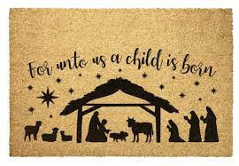
MARCH TO THE MANGER SPECIAL OFFERING

During this Advent Season we will be collecting a special offering to assist in raising funds to support our General Operating Fund.

This fund is used to pay salaries, utilities, program expenses, and Our Church’s Wider Mission through the Missouri Mid-South Conference of the United Church of Christ.

When the offertory hymn is played we will be asking the congregation to come forward to the manger to give a special offering. We will also have the ushers come around to you if you would prefer to remain seated.

Every gift amount helps us continue to provide vital ministry to our local community and beyond, so please give generously. Thank you.
__________________________
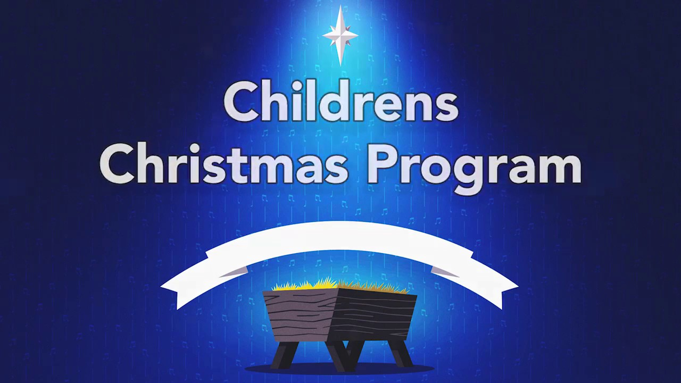
The children’s Christmas program is today during the 10 am worship service.

Special Shout out to the Directors, Teachers and Students!

We are looking forward to sharing with our Faith Family.

The SonShine Kids Club
__________________________
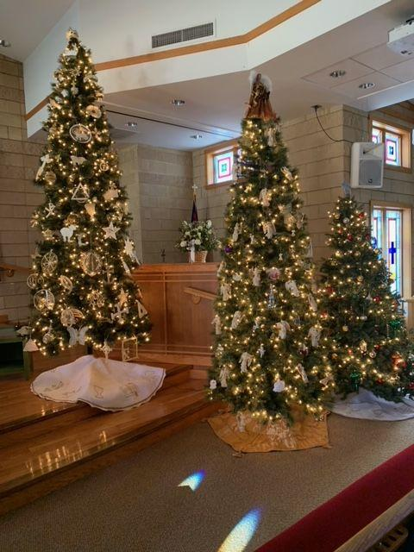

Our Chrismon Tree

You will notice that one of our sanctuary trees is decorated with ornaments not often found on our trees at home. This tree is decorated with ornaments called Chrismons.

What are Chrismons? Chrismons are Christmas decorations styled with Christian symbols. These ornaments remind us of the true meaning of Christmas – the celebration of Jesus’s birthday. Chrismon is a combination of two words Christ and monogram, meaning symbol. This idea was created by Frances Kipps Spencer for her church in Danville Virginia in 1957. The idea quickly spread to other churches and homes. Colors used in their creation are traditionally white and gold. White is the liturgical (or Church) color for Christmas and symbolizes that Jesus was pure and perfect. Gold symbolizes His Majesty and Glory. Symbols include various crosses, anchors, crowns, Alpha and Omega Greek letters, fish, and stars. Each week during Advent we will share the meaning behind some of our Chrismon ornaments.

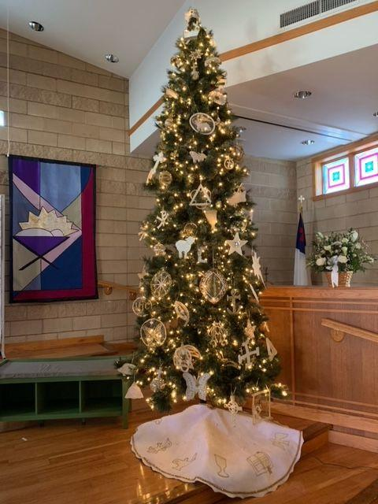

__________________________

The church wishes to thank Greg Hale, Brad Rehm, and Ken Waterman for setting up the nativity scene outside adjacent to Wolfrum Rd.
__________________________

Sunday December 24, 2023 is our Christmas Fund Offering for the Veterans of the Cross and the Emergency Fund. Envelopes will be in the pews for this special donation.
Gifts to the Christmas fund may be made year round at www.christmasfund.org
__________________________
Members of our Handbell Choir, who hosted the December 8th concert by ReBELLion Ensemble of St. Louis, wish to thank members of our church and persons from our community; 116 strong, for their attendance and enthusiastic applause for ReBELLion's outstanding performance.
The free-will offering exceeded $500 - another sign of their sincere appreciation.
ReBELLion's last Christmas Concert will be Sat., Dec. 16th, at 4:00 PM at Kirkwood United Methodist Church. They will be joined by the St. Louis Wind Symphony.
__________________________
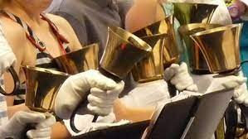
“ JOYFULLY RING HIS PRAISES” HANDBELL MINISTRY

Our choir rings in the 10 AM worship service the 2nd Sunday each month: Sept. thru May

Practices on Wednesday evenings 5:30 to 6:50. August thru mid-May
__________________________

I need empty Quaker Oatmeal boxes - (round, cardboard containers - either size) for use by members of our children's choir.

There is a Box in the fellowship hall by the kitchen you can put the empty containers in.

Thanks, Joyce Ann McClain, Director
__________________________

ST. JOHN’S SINGERS FOR THE SAVIOR

Our Children and Youth Music Program rehearsal is every Sunday at 11:15am following the close of worship and Sunday School. Please contact our Director, Joyce Ann McClain, at 636-441-0121 for more details.

__________________________

Men’s and Women’s Bible Study will be joining together every Tuesday at Scrambled Egg at 9:30am.

Come at 9:30 AM if you want to have breakfast with the men or come between 9:45 - 10 AM if you plan to have breakfast earlier on your own.

Everyone is Welcome!

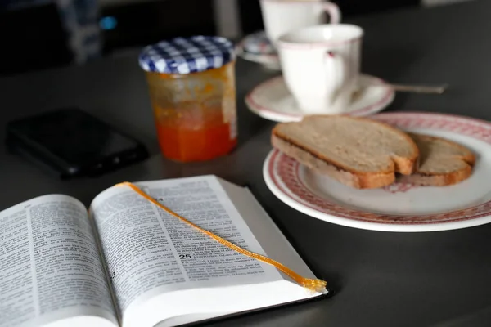
__________________________

Would you like to Volunteer to be a Liturgist, an Usher/Greeter, a Bell Ringer or even a Sound Technician or how about adding yourself to another position?

We are always looking for members. Contact Jewel Nadler 636-373-1860.
__________________________

COUNCIL NEWS

The church council met on Tuesday 11/29 for the final time in 2023.

Major topics included the following:
The repaving and sealing of the parking lot.

A presentation on updated cemetery changes to include the purchase of a flag pole, solar lights and the purchase and planting of 6 trees on the grounds. Other changes of remedial actions will be forthcoming.

The sanctuary computer has been replaced and software reloaded.

We still could use additional help on any of our committees, so if you are interested in helping out, please contact any of the council members. Thank you for your continued support of our church ministries!

Congratulations to the new council officers!

President - Mark Falkner

Vice President - Gina Hale

Secretary - Lisa Kaiser

Many many thanks to outgoing council members Dennis Davenport (who served as president), Loire Kroger (who did a terrific job as secretary), and Polly Wagner.
__________________________
LENDING LIBRARY

Looking for some books to help increase your understanding and inspire your devotion to Jesus?

Check out our new lending library, which is located in the large basket next to the main building doors.

You can take a book, or leave one to share. Just remember to return the book you take within a month, so others can benefit from it as well. Thanks.
__________________________

Fire Up the Grill! We are having our Annual Frostbite BBQ!

Our BBQ is Saturday January 20, 2024.

We are looking for donations and volunteers to help.

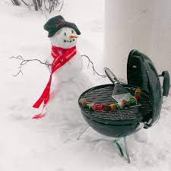

__________________________
F.I.S.H. FOOD PANTRY NEEDS FOR DEC. 2023
Spaghetti (dry)
Tuna Helper
Canned Chili
Broth/Gravy
Canned Chicken
Canned Meats (Spam, Stew)
Jello
Pie Filling
Kleenex
Toilet Tissue
Body Wash
Diapers - Newborn
Pull Ups - Any Size
Kids Shoes & Boots - All Sizes & Genders - New or Lightly Worn
Queen and Twin fitted sheets
Blankets

We sincerely thank you and send you our warmest wishes for a blessed Christmas and safe New Year, The FISH family
Place your donations in the grocery cart in the fellowship hall.
__________________________
MISSION & CARING
MINISTRIES TEAM NEWS

Homebound? If you know of someone who should be included on our shut-in list to receive quarterly Holy Communion from the minister and occasional visits
and gifts from our team, please contact the church office.

Festival of Sharing Eyeglass Collection Old eyeglasses or sunglasses need to be Prescription glasses. They can be dropped off in the bin in fellowship hall. We cannot take glass cases or non-prescription sunglasses.
______________________
Support Ronald McDonald House - bring in your soda tabs!

Come join us… Mission & Caring meets on the second Tuesday of each month in the fellowship hall at
6pm
__________________________

The Hat, Mitten and Scarf Tree was beautifully decorated by the congregation's generous donations.

The Shower of Love will be receiving:
38 Hats
51 Pairs of Gloves/Mittens
6 Mitten and Mitten Set
32 Scarves
to distribute to kids in need of items to stay warm this winter.`
Thank you everyone!

There are angels on the tree in the Fellowship Hall, today is the last day!

If the angel is asking for a gift card to a store or a monetary gift to assist the family with utility bills, place it in the envelope attached to
the angel and put it in the offering plate with the angel.

Please make checks payable to St. John’s UCC and on the memo line write angel tree. Thank you in advance for your generosity and helping to make this family’s Christmas special.

__________________________
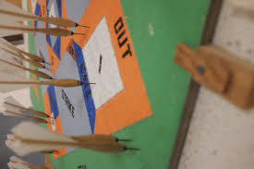

ST. JOHN’S MENS DART BALL SCHEDULE
GAMES START AT 7:30P.M.

Monday, Dec. 18
Our Savior @ St. Johns
Friedens - Bye

If you are interested in joining the Men's team call Dick Wade at 636-448-0238
__________________________
ANNOUNCEMENTS!! Are you receiving messages from the Church!!

“One Call Now” is the phone alert system we use to get the word out to our friends and members about important events, weather-related cancellations, meeting reminders, bereavement notices and more.

If you miss the voice call, the system will leave a message on your voicemail. If the message gets cut off, simply dial 1-877-698-3261 to retrieve the message in its entirety.

If you are not receiving the One Call Now notices and would like to, please contact the church office at 636-926-8995.
__________________________

In case of bad weather, cancellations will be made on our One Call system if you need to add your phone number to the system, contact the office and we will get you added.

If you miss the voice call, the system will leave a message on your voicemail. If the message gets cut off, simply dial 1-877-698-3261 to retrieve the message in its entirety.

Everyone please be safe!
__________________________

Reminder: If you have a change of address or change in phone number please reach out to the church office 636-926-8995 so we can update our files.
__________________________
OUR HOMEBOUND FRIENDS

Martha Cook
Shelia Fredrick Rita Marcum
Calvin Hagen Chris Savage
Barb Hofstetter George Schlie
Pat Honaker Edie Shave
Don Howell Rick Weaver Hank Kroeger
Mary Ellen Dieckmann David & Dorothy Kapeller
__________________________
Don't forget to bring your recycled cans to church!

There is a canister out in the trash coral that is marked

"Aluminum Cans"
__________________________

John & Sharon Hampshire 12/10
__________________________

Martha Cook 12/02
Howard Hoskins 12/08
Dana Fehr 12/13
Alice Gooch 12/14
Karen Gruber 12/14
Ann Gaadt 12/18
Jill Carr 12/19
Dorothy Kapeller 12/20
Sharon Kolkmeier 12/20
Mary Lafser 12/20
Shaun Johnson 12/24
Terry Howell 12/25
Kraig Kassel 12/30
__________________________
ALTAR FLOWERS

Is there someone that you would like to remember, or honor? Special anniversary, birthday, or graduation to recognize?

If so, contact the church office (636) 926-8995 to sponsor chancel flowers in their name(s). The cost is $35 per arrangement
__________________________
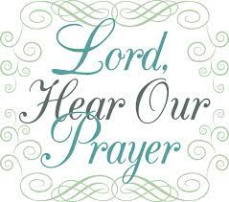
PRAYER LIST

Prayer request cards are located on the small table as you enter for worship.

Please fill one out and give it to the Minister or an Usher. Make sure you have the person’s permission before filling out a card.

Comfort and Healing: Diane Faulkner; Debbie Kolkmeier and Family; The Lonning Family; The Gilliam Family; Gerri Russo; Mary Ellen Dieckmann; Martha Cook; Edie Shave (Hospice); Hank Kroeger.

Others for whom we have concern: Karen Tucker (Friend of Rhonda Hanne’s recovering from knee surgery); Neala Bowan (Friend of the Wooten’s diagnosed with brain cancer); Ronnie Vasquez (Son-in-Law of Barb Eickmeier); Ron Gravemann, (Brother of Diane Falkner); Eric (Allan Hopkins, niece’s husband 46 years old diagnosed with stage 4 Pancreatic Cancer); Michael Wooten (Father-In-Law of Natalie Wooten, diagnosed with Lung Cancer); Diane Weilmuenster (Heart Problems, Sister of David & Jill Carr); Michell Lenz (Niece of Jeff & Debbie Kolkmeier Diagnosed with Breast Cancer); Janet Iler (Brain Cancer Surgery, friend of Rhonda Hanne); Shannon Boland and Family (friend of Connie Wildt, battling cancer); Dylan Jensen (per Jinnielynn Howell); Samantha Weaver (having tests run, daughter of Mary Trostel).

Please let us know when it’s time to remove a request from the list.
______________________

Rev. Patrick Gruber
Church Pastor

~~~~~~~~~~~~~~~~~~~~~~~~~~~~~~~~~~~~~~~~~~~~~~~~~~~~~~~~
Mary Trostel
Office Administrator
Office Hours: M-F, 9 a.m. to 3 p.m.
Office@stjohnsweldonspring.com
St. John’s UCC 945 Wolfrum Rd., Weldon Spring MO, 63304 | Phone:
(636) 926-8995
www.stjohnsweldonspring.com

