Weekly Announcements
12/24/2023
…………………….
This Week’s Participants:

Church Pastor;
Rev. Patrick Gruber

Organist Pianist & Choir Director; Ann Gaadt

Organist Pianist;
Ken Waterman

Handbell Director & Children’s & Youth Choir Director;
Joyce Ann McClain

Liturgist;
Jewell Nadler

Greeter;
Connie Wildt (10am),
Jewell Nadler (4pm)

Ushers;
Ken Waterman, Connie Wildt,
Jerry & Polly Wagner (10am)
Donna Bleeckert, Jewell Nadler, Mark Leuthauser, (4pm)

Sound Booth;
Jean Hoskins, Bill Cunningham (10am), David Carr and
Bill Cunningham (4pm)

Bell Ringer;
Jerry Wagner (10am),
Greg Hale (4pm)

Nursery;
Kay Haines, Dana Fehr

SonShine Kids;
Dottie Seiter and Melissa Anstedt

Pastoral Care: If you find yourself experiencing illness, hospitalization, grief, or other critical challenges, contact us at (636) 926-8995. For emergencies, contact Pastor Patrick Gruber, (636) 253-1287.

Financial Contributions: you can give electronically via our website, set up automatic monthly contributions, or receive weekly envelopes, contact the office for assistance.

Announcements: If you would like to have something announced in the bulletin, please email the information to office@stjohnsweldonspring.com no later than 10 a.m. each Thursday. Thank you!

Use your QR reader app to make an electronic contribution to St. John’s UCC. Thank you. ______________________
Last Week’s Worship Attendance: 96 Facebook Views: 90 YouTube Channel Views: N/A
______________________
THIS WEEK’S
TOP STORIES
__________________________

It is really important that we don't forget to wear name tags every Sunday.

If you need a name tag (members & non-members) call the office and Mary will make sure to get you one.
__________________________
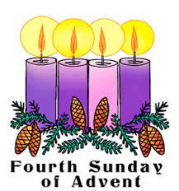

Candle Lighters 10am: Adam & Melissa Averett
~~~~~~~~~~~~~~~~~~~~~~~~~~~~~~~

Candle Lighters 4pm: Bill & Karla Cunningham
__________________________

HOLIDAY HOURS
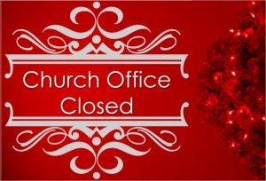

Church Office Closed, Monday December 25th and Tuesday December 26th.

Merry Christmas Everyone!
__________________________

There will be NO Coffee Hour after the Worship Services this Sunday.
__________________________

MARCH TO THE MANGER SPECIAL OFFERING

During this Advent Season we will be collecting a special offering to assist in raising funds to support our General Operating Fund.

This fund is used to pay salaries, utilities, program expenses, and Our Church’s Wider Mission through the Missouri Mid-South Conference of the United Church of Christ.

Every gift amount helps us continue to provide vital ministry to our local community and beyond, so please give generously. Thank you.
__________________________

Today is our Christmas Fund Offering for the Veterans of the Cross and the Emergency Fund. Envelopes will be in the pews for this special donation.

Gifts to the Christmas fund may be made year round at www.christmasfund.org
__________________________
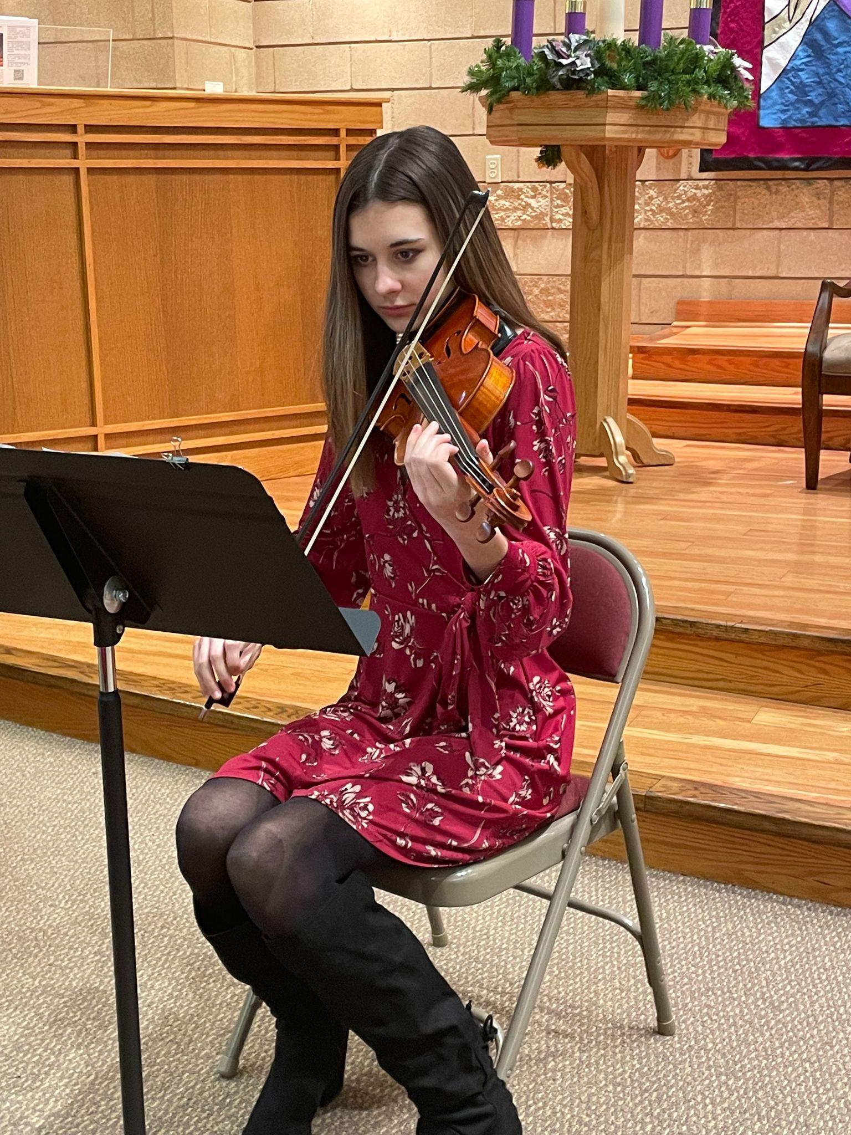
A BIG Shout out to Delaney Jergensmeyer for her Violin Solo at Sunday Dec. 3rd Worship Service.
So beautful!
__________________________
Our 2024 Stewardship pledge card report!
We had 43 respondents pledge $156,668 to the Operating Fund.
This represents 61.9% of our $253,095 Budget. In addition, $5,380 was pledged to the Building and Ministry Expansion Fund.
This compares to the 2023 Stewardship Campaign of 46 pledges totaling $158,161 or 62.5% of the $253,936 2023 budget.
__________________________
The Financial Summary for October, 2023.
This month we had a loss of $1,066 which was unfavorable to the budget by ($591).
Operating revenue was $16,198, unfavorable to budget by ($4,963).
Operating expenses were $17,264, favorable to the budget by $4,372.
The Building and Ministry Expansion Fund is $199,626.

This reflects a regular increase of $981.

There were no other revenue or expense items that were not normal budget activity.
__________________________
The Financial Summary for November, 2023.

This month we had a net income of $1,964 which was favorable to the budget by $1,169.

Operating revenue was $16,235, unfavorable to budget by ($4,927).

Operating expenses were $14,270, favorable to the budget by $6,036.

The Building and Ministry Expansion Fund is $200,507.
This reflects a regular increase of $881.

There were no other revenue or expense items that were not normal budget activity. __________________________
The Ladies of St. John’s UCC had their Christmas Luncheon, good times were had by all.

Thank you, Jean Hoskins for organizing and thank you Pastor Pat for the entertainment! Haha!

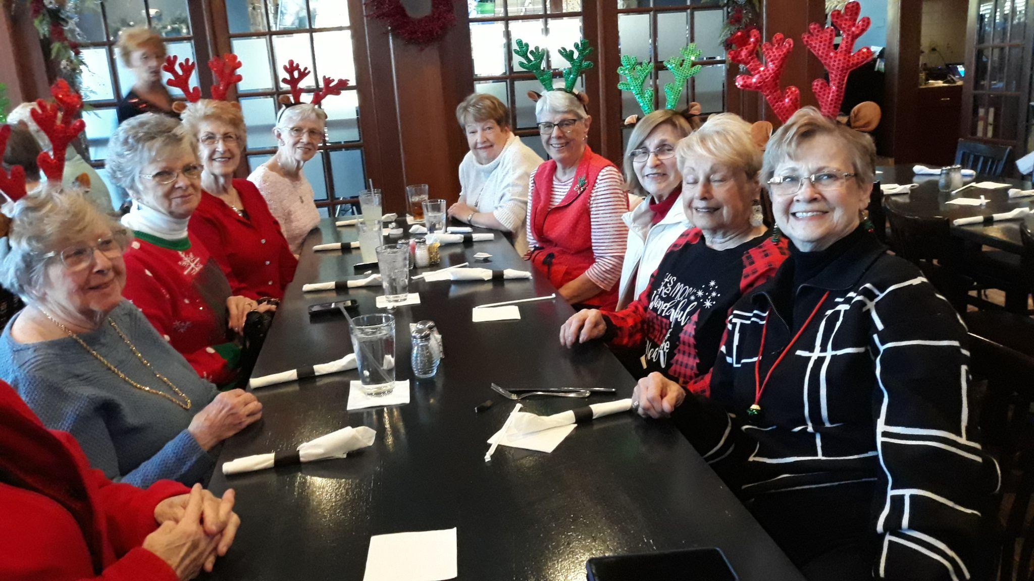
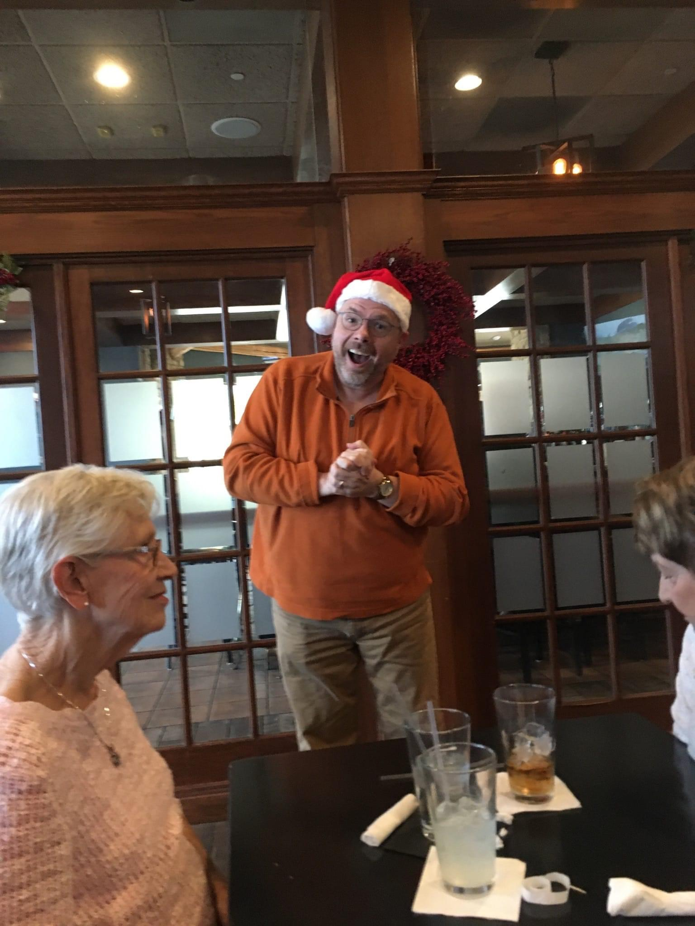

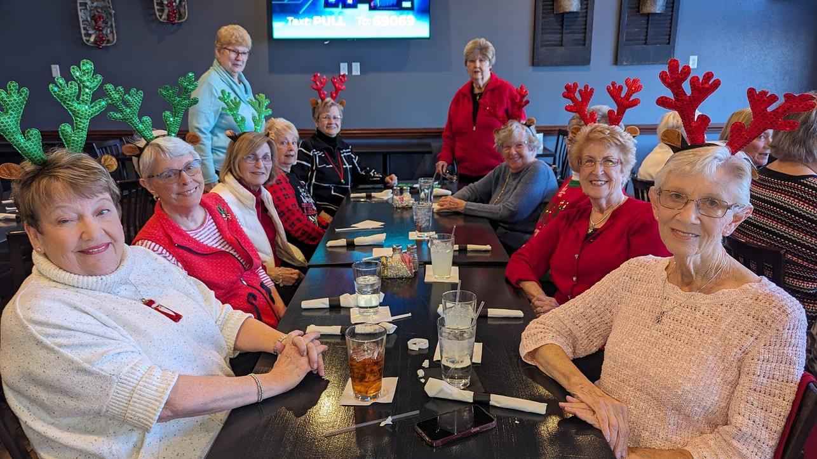
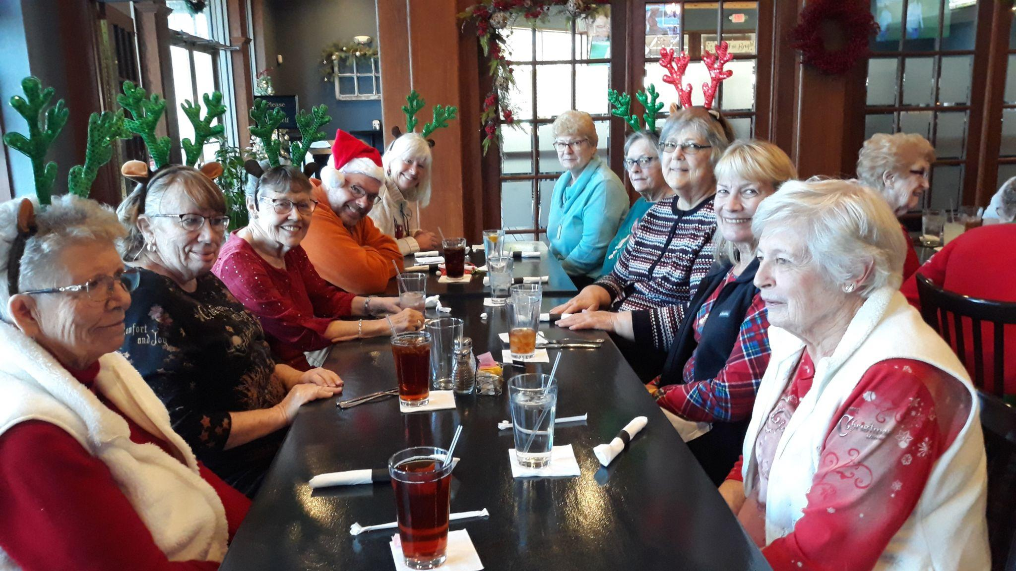
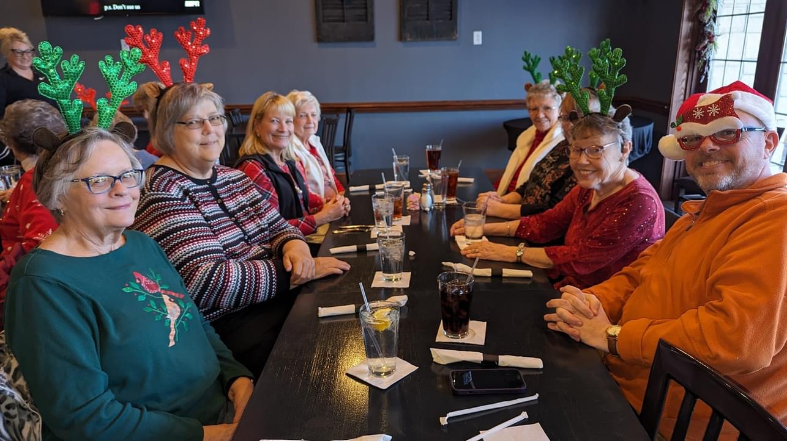
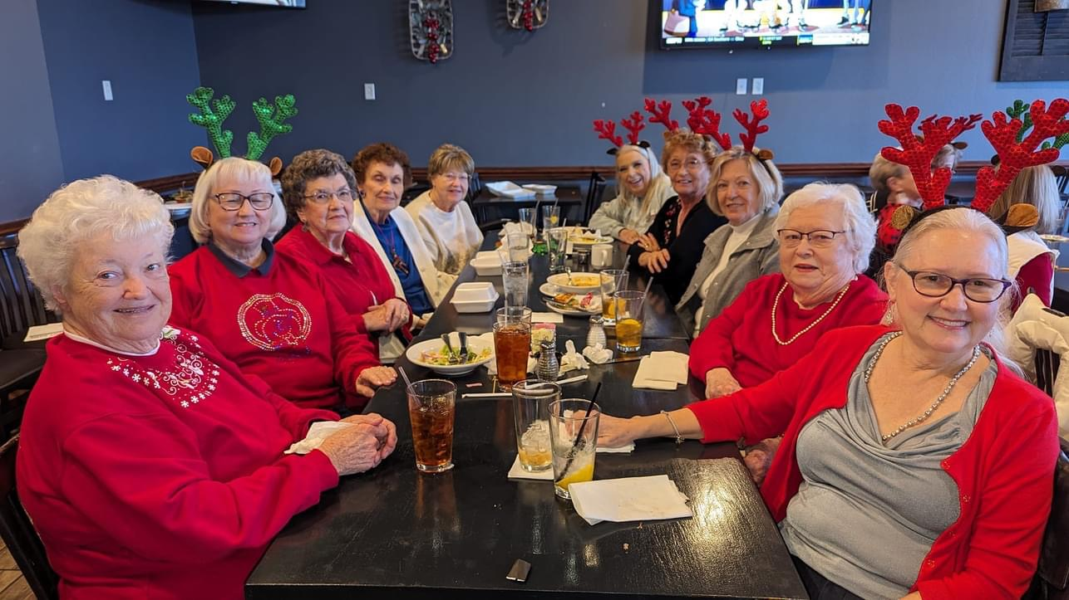
__________________________

“ JOYFULLY RING HIS PRAISES” HANDBELL MINISTRY

Our choir rings in the 10 AM worship service the 2nd Sunday each month: Sept. thru May

Practices on Wednesday evenings 5:30 to 6:50. August thru mid-May
__________________________
I need empty Quaker Oatmeal boxes - (round, cardboard containers - either size) for use by members of our children's choir.

There is a Box in the fellowship hall by the kitchen you can put the empty containers in.

Thanks, Joyce Ann McClain, Director
__________________________
ST. JOHN’S SINGERS FOR THE SAVIOR

Our Children and Youth Music Program rehearsal is every Sunday at 11:15am following the close of worship and Sunday School.

Please contact our Director, Joyce Ann McClain, at 636-441-0121 for more details.

__________________________

Men’s and Women’s Bible Study

Will Not Meet this week!

__________________________
Would you like to Volunteer to be a Liturgist, an Usher/Greeter, a Bell Ringer or even a Sound Technician or how about adding yourself to another position?

We are always looking for members. Contact Jewel Nadler 636-373-1860.
__________________________

COUNCIL NEWS

The church council met on Tuesday 11/29 for the final time in 2023.

Major topics included the following:
The repaving and sealing of the parking lot.

A presentation on updated cemetery changes to include the purchase of a flag pole, solar lights and the purchase and planting of 6 trees on the grounds. Other changes of remedial actions will be forthcoming.

The sanctuary computer has been replaced and software reloaded.

We still could use additional help on any of our committees, so if you are interested in helping out, please contact any of the council members. Thank you for your continued support of our church ministries!

Congratulations to the new council officers!

President - Mark Falkner

Vice President - Gina Hale

Secretary - Lisa Kaiser

Many many thanks to outgoing council members Dennis Davenport (who served as president), Loire Kroger (who did a terrific job as secretary), and Polly Wagner.
__________________________
LENDING LIBRARY

Looking for some books to help increase your understanding and inspire your devotion to Jesus?
Check out our new lending library, which is located in the large basket next to the main building doors.
You can take a book, or leave one to share. Just remember to return the book you take within a month, so others can benefit from it as well. Thanks.
__________________________

Fire Up the Grill! We are having our Annual Frostbite BBQ!

Our BBQ is Saturday January 20, 2024.

We are looking for donations and volunteers to help.

__________________________

F.I.S.H. = Friends in Serving Him

F.I.S.H. FOOD PANTRY NEEDS FOR Jan. 2024
Pasta sides
Pudding Jello- dry
Spaghetti Sauce Hamburger Helper
Tuna Helper
Canned Chicken
Canned Meats (Spam, Stew)
Instant Coffee
Tea Bags
Dish Soap
~~~~~~~~~~~~~~~~~~~~~~~~~~~~~~~

Please know that these are items we never sell, they are strictly given free of charge to those who need emergency help.

Nothing listed needs to be new or even matching.

Housewares: drinking glasses, mugs, cereal/soup bowls, plates, silverware and pots/pans non-Teflon

Linens: Queen/double bed sheets, blankets, pillow cases, towels- both hand and bath, wash cloths

Childrens: shoes, boots, coats
Pull-ups and diapers- large sizes
These are all items we have to purchase when our donations run out. We’re thrilled if we get them year-round.
Can’t thank you enough for your offer to help

The FISH family

Place your donations in the grocery cart in the fellowship hall.
__________________________
MISSION & CARING
MINISTRIES TEAM NEWS

Homebound? If you know of someone who should be included on our shut-in list to receive quarterly Holy Communion from the minister and occasional visits
and gifts from our team, please contact the church office.

Festival of Sharing Eyeglass Collection Old eyeglasses or sunglasses need to be Prescription glasses. They can be dropped off in the bin in fellowship hall. We cannot take glass cases or non-prescription sunglasses.
______________________
Support Ronald McDonald House - bring in your soda tabs!

Come join us… Mission & Caring meets on the second Tuesday of each month in the fellowship hall at
6pm

__________________________
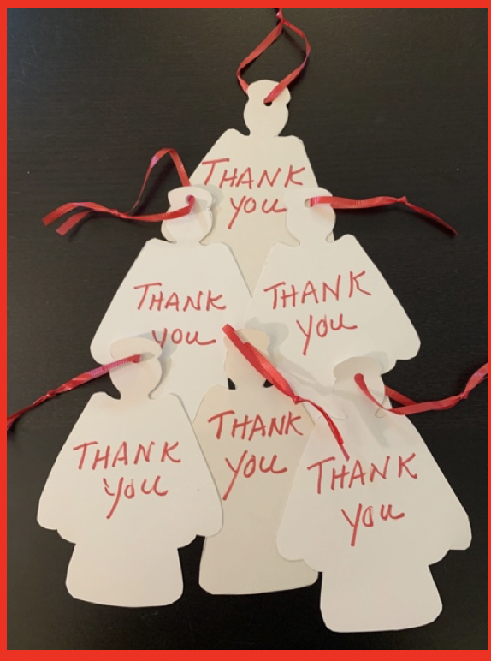
ANGEL TREE

A big thank you to everyone that helped meet our expectations for our adopted family!

We had more money for their utilities than what we expected!!!

You helped a needy family!

The mother was crying and she was so overwhelmed .

Thanks again!
The mission and caring committee

__________________________

ST. JOHN’S MENS DART BALL SCHEDULE
GAMES START AT 7:30P.M.

15-Jan-24
Our Savior @ Friedens
St. John’s Bye

22-Jan-24
St. John’s WS @ Friedens
Our Savior Bye

29-Jan-24
St. John’s @ Our Savior
Friedens - Bye
If you are interested in joining the Men's team call Dick Wade at 636-448-0238
__________________________
ANNOUNCEMENTS!! Are you receiving messages from the Church!!

“One Call Now” is the phone alert system we use to get the word out to our friends and members about important events, weather-related cancellations, meeting reminders, bereavement notices and more.

If you miss the voice call, the system will leave a message on your voicemail. If the message gets cut off, simply dial 1-877-698-3261 to retrieve the message in its entirety.

If you are not receiving the One Call Now notices and would like to, please contact the church office at 636-926-8995.
__________________________

In case of bad weather, cancellations will be made on our One Call system if you need to add your phone number to the system, contact the office and we will get you added.

If you miss the voice call, the system will leave a message on your voicemail. If the message gets cut off, simply dial 1-877-698-3261 to retrieve the message in its entirety.

Everyone please be safe!
__________________________

Reminder: If you have a change of address or change in phone number please reach out to the church office 636-926-8995 so we can update our files.
__________________________
OUR HOMEBOUND FRIENDS
Martha Cook
Shelia Fredrick Rita Marcum
Calvin Hagen Chris Savage
Barb Hofstetter George Schlie
Pat Honaker Edie Shave
Don Howell Rick Weaver Hank Kroeger
Mary Ellen Dieckmann David & Dorothy Kapeller

__________________________

Don't forget to bring your recycled cans to church!

There is a canister out in the trash coral that is marked
"Aluminum Cans"
__________________________

John & Sharon Hampshire 12/10
__________________________

Ann Gaadt 12/18
Jill Carr 12/19
Dorothy Kapeller 12/20
Sharon Kolkmeier 12/20
Mary Lafser 12/20
Shaun Johnson 12/24
Terry Howell 12/25
Kraig Kassel 12/30
___________________
Jerry Wagner 01/05
__________________________
ALTAR FLOWERS

Is there someone that you would like to remember, or honor? Special anniversary, birthday, or graduation to recognize?

If so, contact the church office (636) 926-8995 to sponsor chancel flowers in their name(s). The cost is $35 per arrangement
__________________________
PRAYER LIST

Prayer request cards are located on the small table as you enter for worship.

Please fill one out and give it to the Minister or an Usher. Make sure you have the person’s permission before filling out a card. Please let the Office know when someone can be removed from the prayer list.

Comfort and Healing: Ann Lippincott (Neck Surgery); Sharon Kolkmeier; Diane Faulkner; Debbie Kolkmeier and Family; The Lonning Family; The Gilliam Family; Gerri Russo; Mary Ellen Dieckmann; Martha Cook; Edie Shave (Hospice); Hank Kroeger.

Others for whom we have concern: Sally McBride (Diagnosed with throat cancer, friend of David & Jill Carr); Karen Tucker (Friend of Rhonda Hanne’s recovering from knee surgery); Neala Bowan (Friend of the Wooten’s diagnosed with brain cancer); Ron Gravemann, (Brother of Diane Falkner); Eric (Allan Hopkins, niece’s husband 46 years old diagnosed with stage 4 Pancreatic Cancer); Michael Wooten (Father-In-Law of Natalie Wooten, diagnosed with Lung Cancer); Michell Lenz (Niece of Jeff & Debbie Kolkmeier Diagnosed with Breast Cancer); Janet Iler (Brain Cancer Surgery, friend of Rhonda Hanne); Shannon Boland and Family (friend of Connie Wildt, battling cancer); Dylan Jensen (per Jinnielynn Howell); ______________________

Rev. Patrick Gruber
Church Pastor

~~~~~~~~~~~~~~~~~~~~~~~~~~~~~~~~~~~~~~~~~~~~~~~~~~~~~~~~
Mary Trostel
Office Administrator
Office Hours: M-F, 9 a.m. to 3 p.m.
Office@stjohnsweldonspring.com

St. John’s UCC 945 Wolfrum Rd., Weldon Spring MO, 63304 | Phone:
(636) 926-8995
www.stjohnsweldonspring.com

